**SPLUNK**

**Splunk Beginner to Architect**

**Section 8: Distributed Splunk Architecture:**

1. **Overview of disturbed Splunk architecture:**

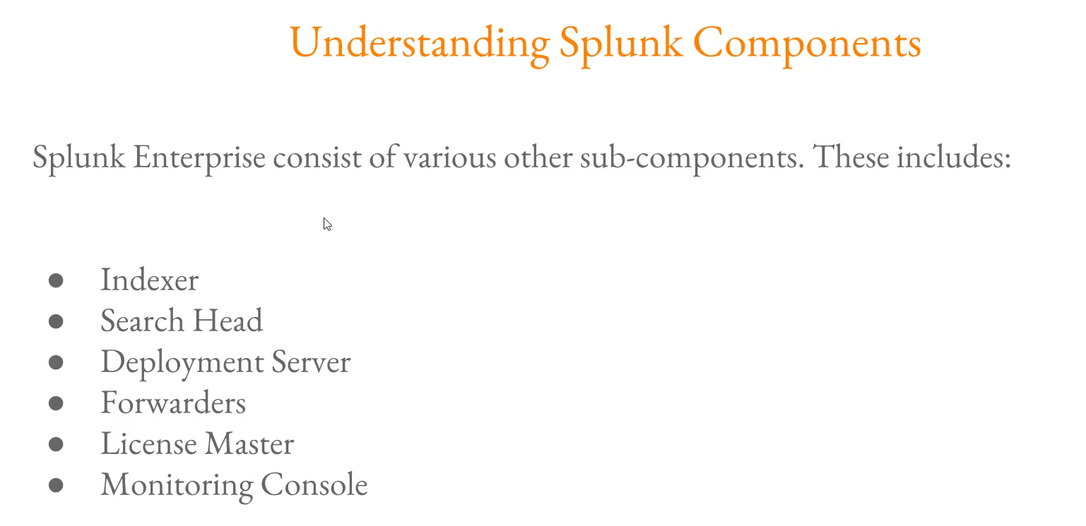

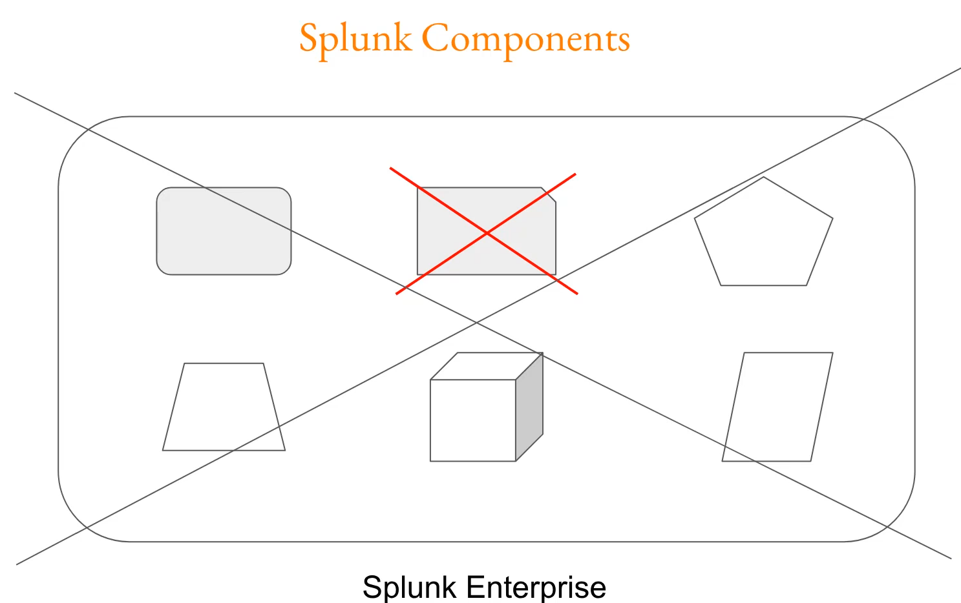

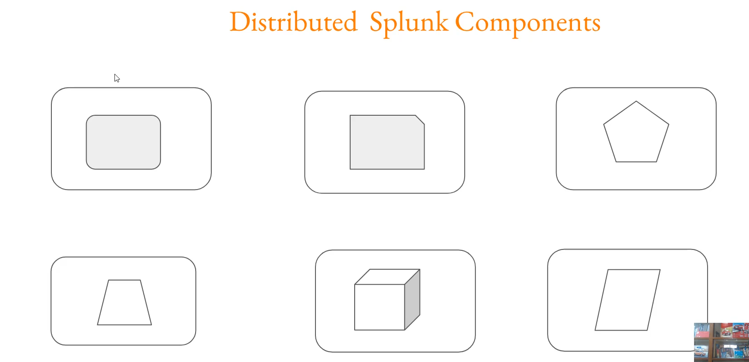

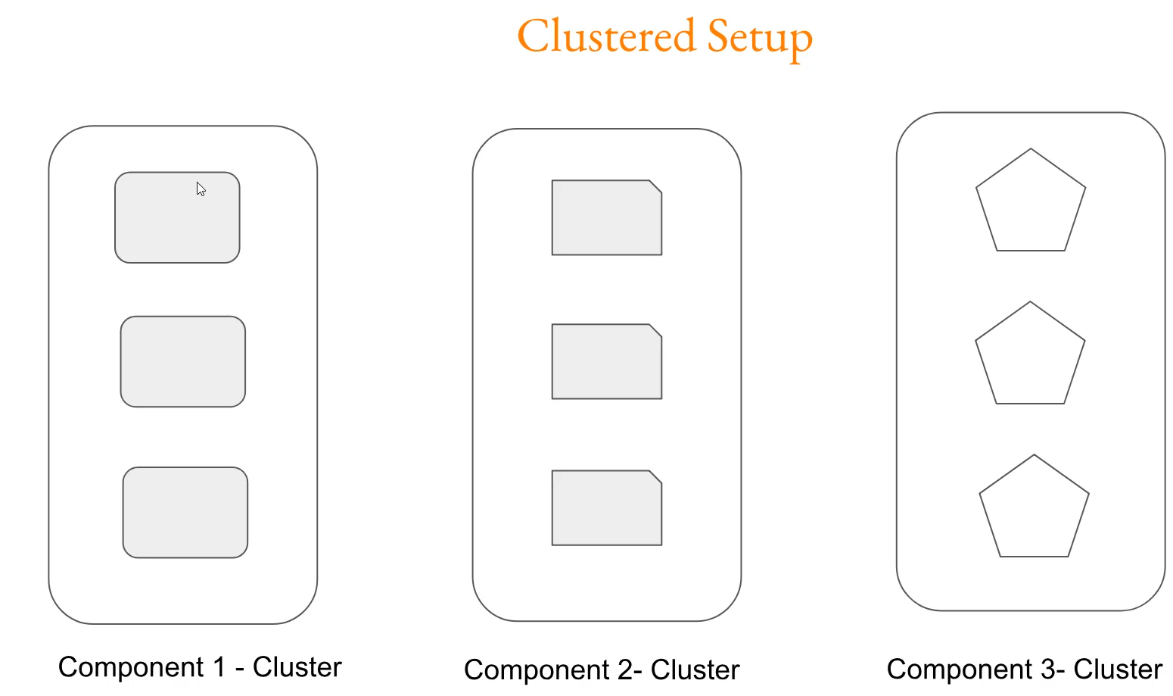

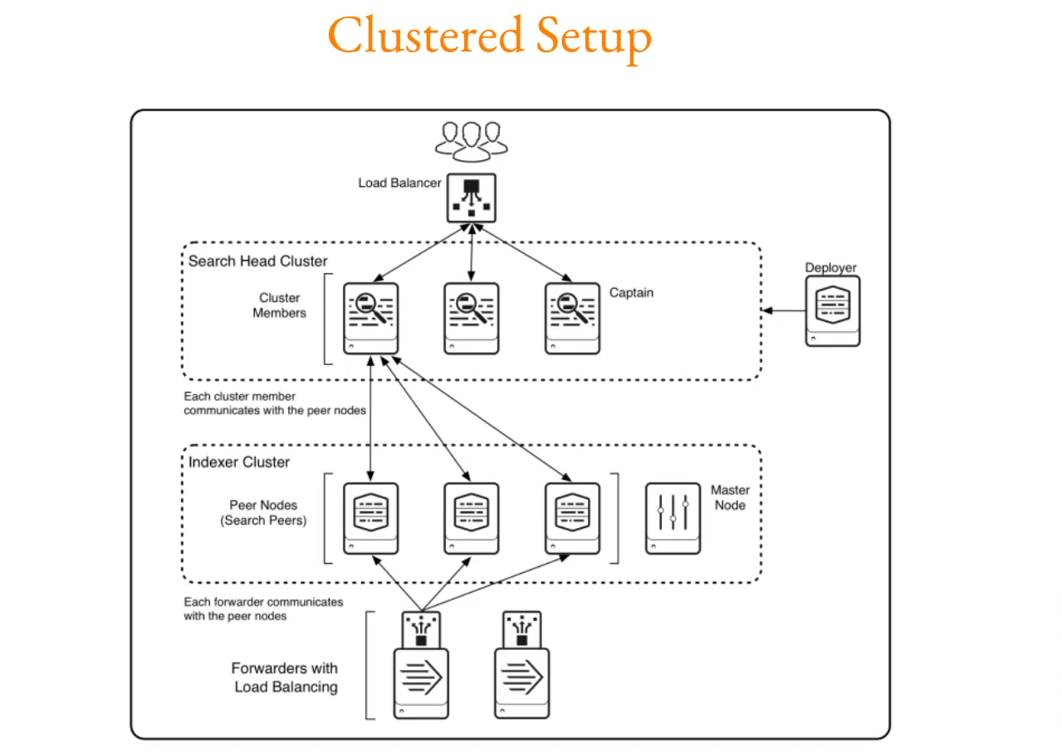

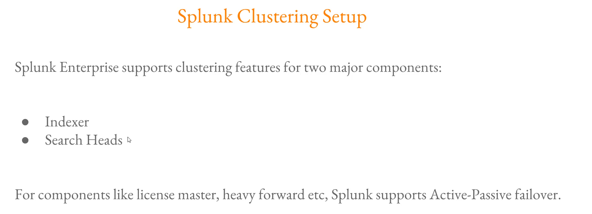

**Splunk Architecture & Deployment Summary**

You covered the core components and the three main types of deployment:

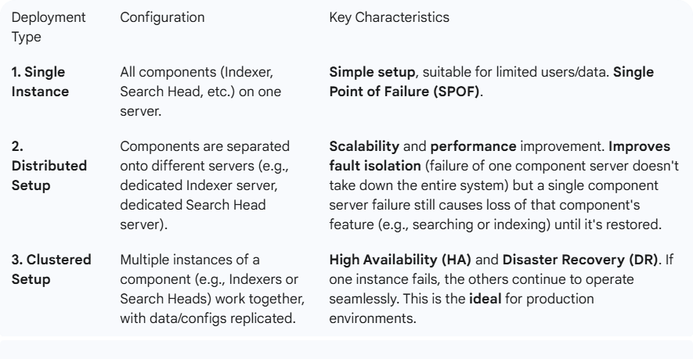

**Core Splunk Components and Their Roles**

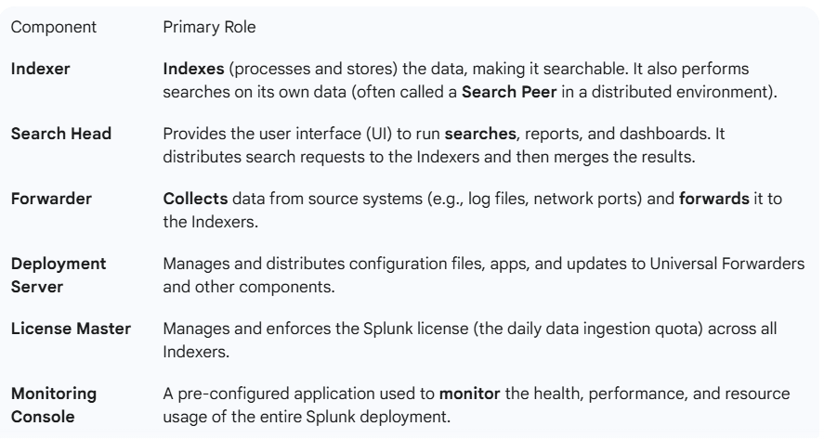

**Clustering vs. Active-Passive Failover**

You made a critical distinction regarding component resilience:

* **Clustering (Active-Active HA):** This is where multiple nodes are *actively* working, sharing the load, and constantly replicating data/configuration. If one node fails, the others immediately and seamlessly take over its tasks.
  + **Components that support Clustering:** **Indexer** (via the Indexer Cluster) and **Search Head** (via the Search Head Cluster).
* **Active-Passive Failover:** This is where one component is *active*, and one or more are *passive* (standby). If the active component fails, the passive component must be promoted or manually switched to become active. This is simpler to implement for certain components but may involve a brief period of downtime during the transition.
  + **Components that typically use Active-Passive HA/Redundancy:** **License Master** and **Cluster Master** (the manager of the Indexer Cluster).

===================================================================================

1. **Understanding License Master:**

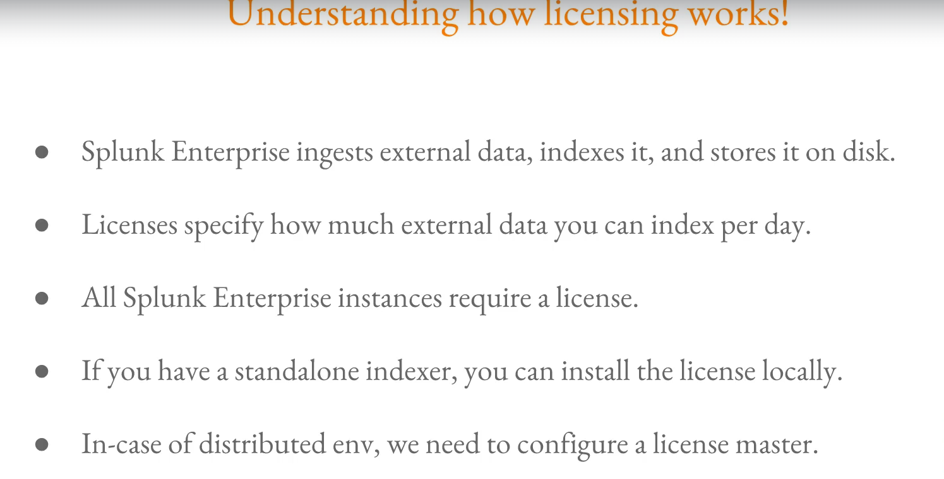

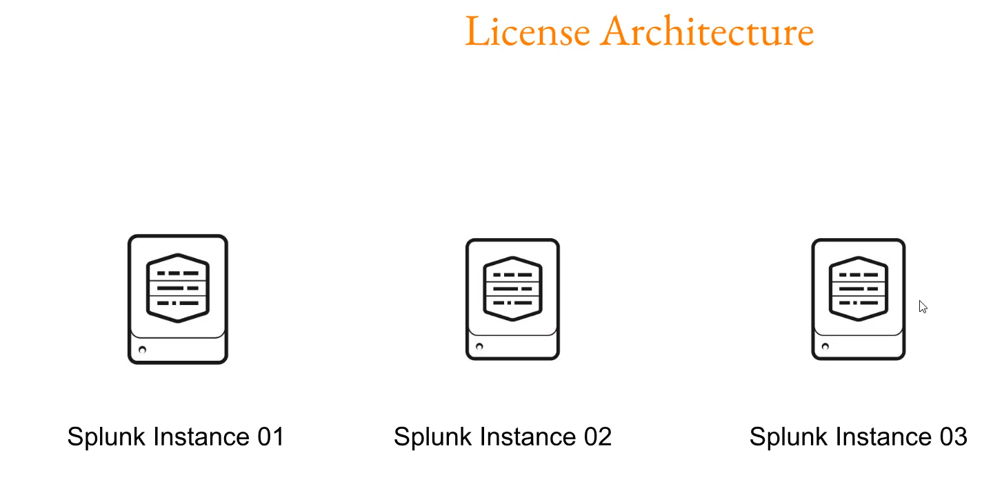

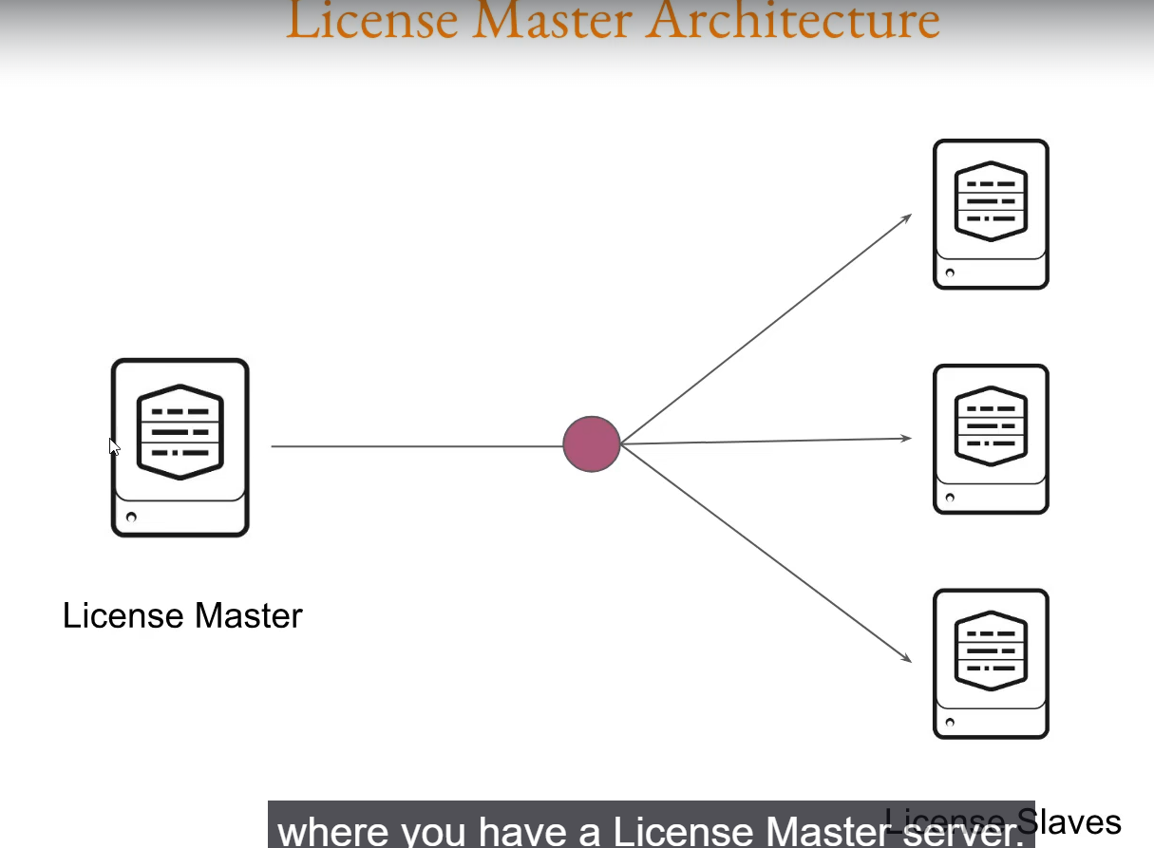

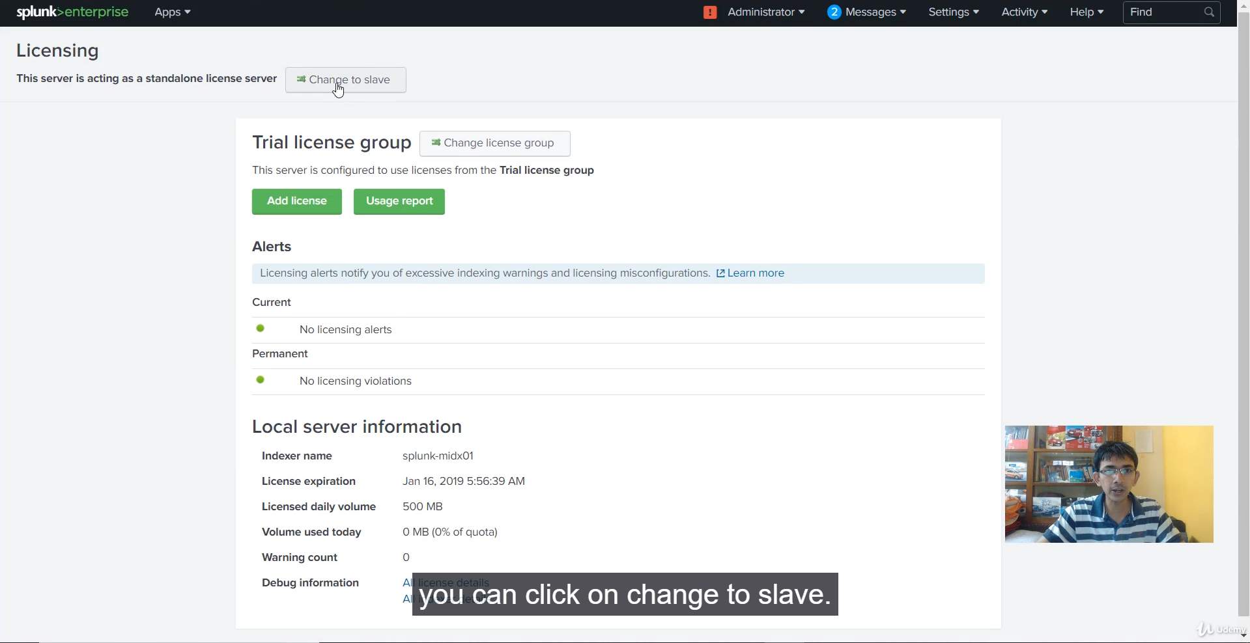

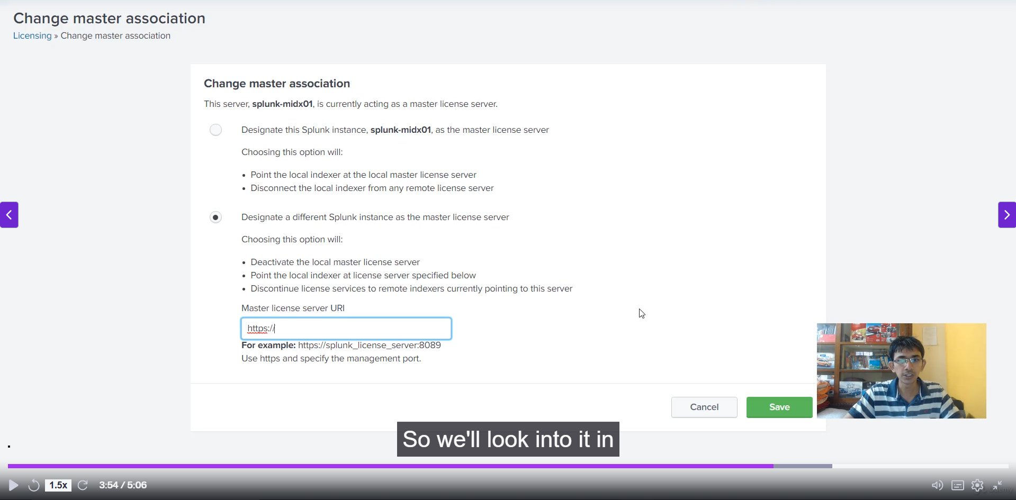

**Splunk Licensing and License Master: Key Concepts:**

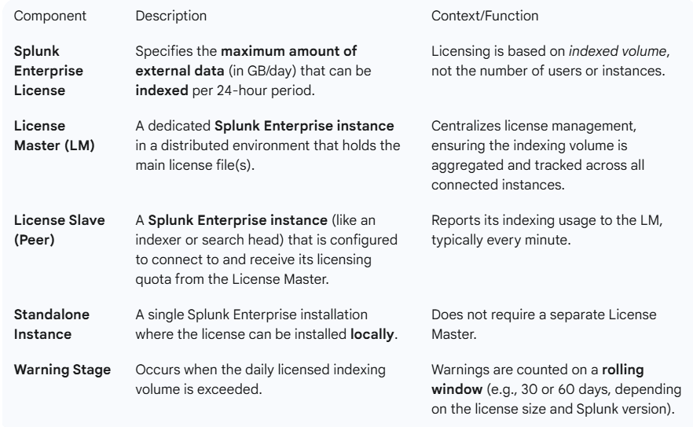

**Understanding License Violations**

You mentioned exceeding the license volume leads to a warning. This is a critical area for administrators.

* **Warning:** Occurs when the daily licensed volume is exceeded in a 24-hour period.
  + You receive a notification and have until midnight on the License Master to resolve the issue (e.g., stop data ingestion, increase license size).
* **Violation:** Occurs after accumulating a certain number of warnings in a rolling time period (e.g., **5 or more warnings in a rolling 30-day period** for Enterprise licenses < 100GB in older versions).
* **Impact of Violation:**
  + **Indexing Continues:** Splunk **does not stop indexing** data, ensuring you don't lose critical information.
  + **Search Disabled:** For smaller licenses (< 100 GB), all **search capabilities are blocked** (including scheduled reports and alerts) until the license is no longer in violation. Searches against the internal indexes (_internal) for troubleshooting usually remain functional.
  + **Broken Connection:** If a **License Slave cannot communicate** with the License Master for **72 hours or more**, the slave will enter a violation state, and its search will be blocked.

**🛡️ High Availability for the License Master**

In a production environment, the License Master is a critical Single Point of Failure (SPOF). While Splunk allows for 72 hours of operation without a License Master, a robust strategy is important.

* **Splunk's Native HA:** By default, Splunk **does not** offer a built-in, active-active high availability feature for the License Master like it does for Indexer or Search Head Clusters.
* **Common Workaround:** The common practice for License Master High Availability is a **manual/external active-passive setup**, which involves:
  1. Installing the license on **two separate** Splunk instances (License Master 1 and a designated standby instance).
  2. Pointing all License Slaves to a **DNS alias** or **Load Balancer URI**.
  3. In a failure scenario, the DNS record or Load Balancer is updated to point to the standby instance, and the standby instance is manually activated as the new License Master.
* **Special Licensing (For select customers):** Splunk offers a **High Availability Redundancy** feature for specific Enterprise License Agreements, which allows using multiple License Managers behind a load balancer with automatic syncing for better resilience.

===================================================================================

1. **Implementing License Master:**

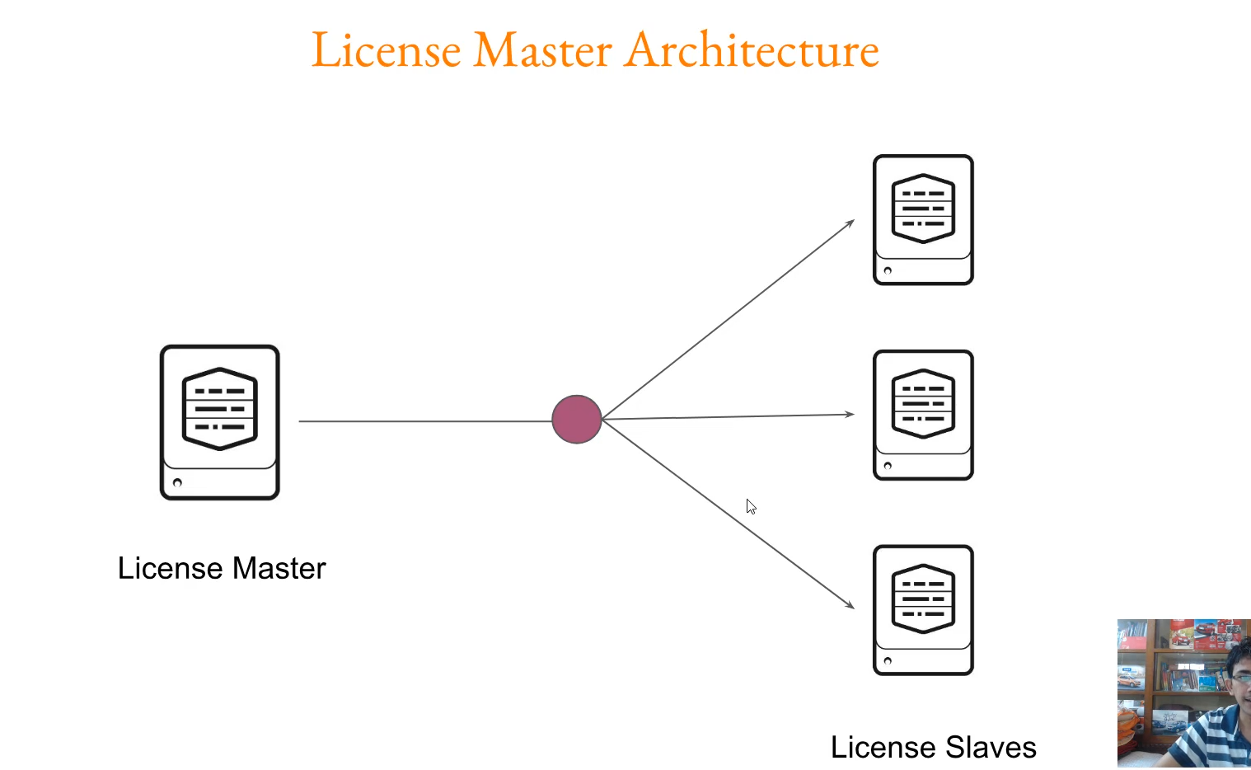

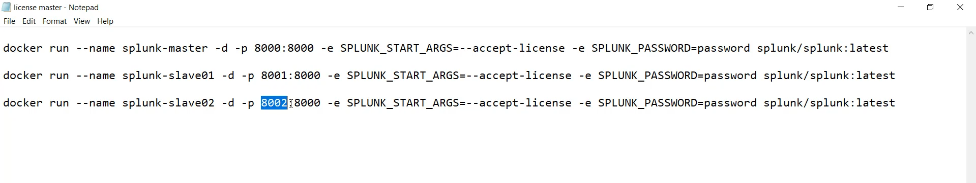

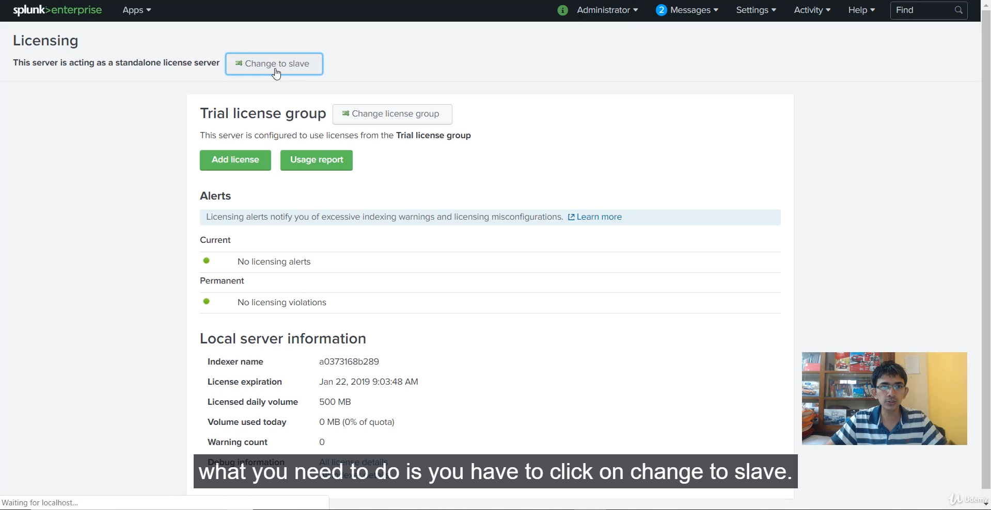

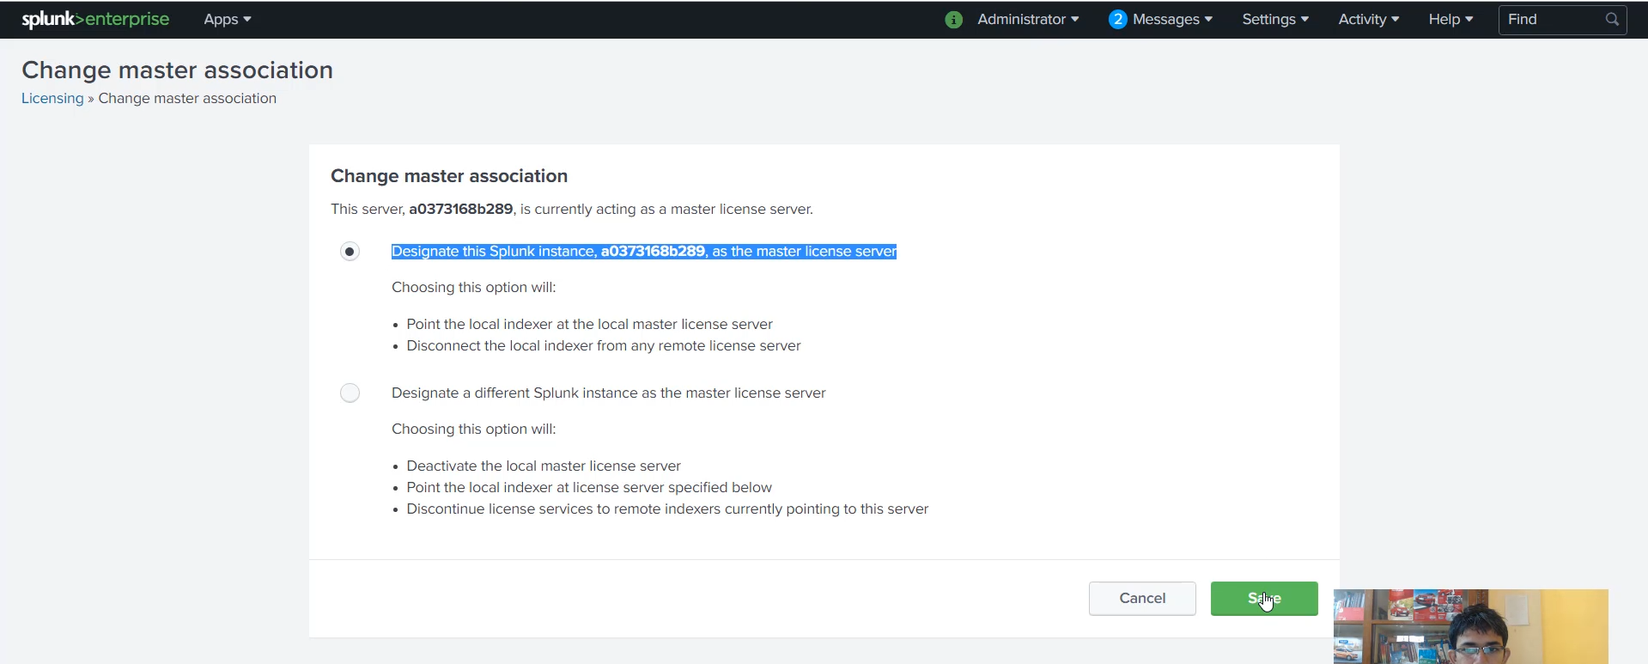

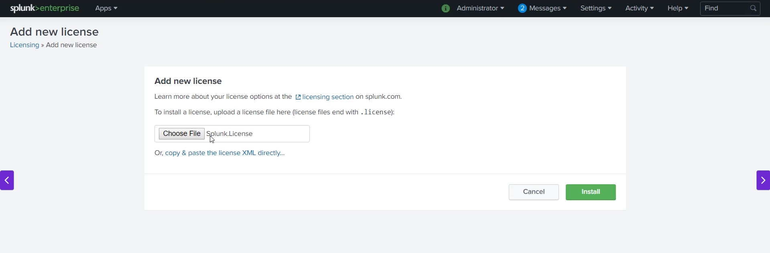

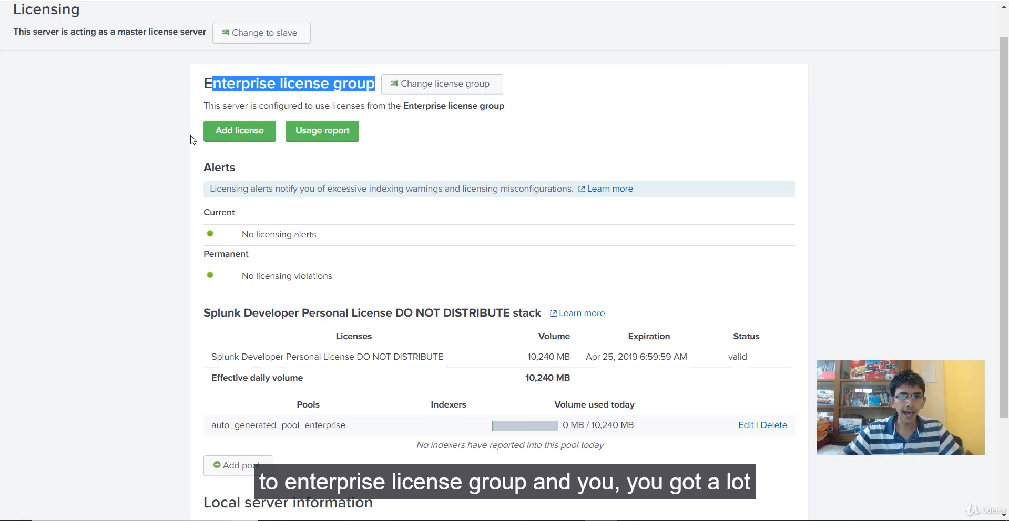

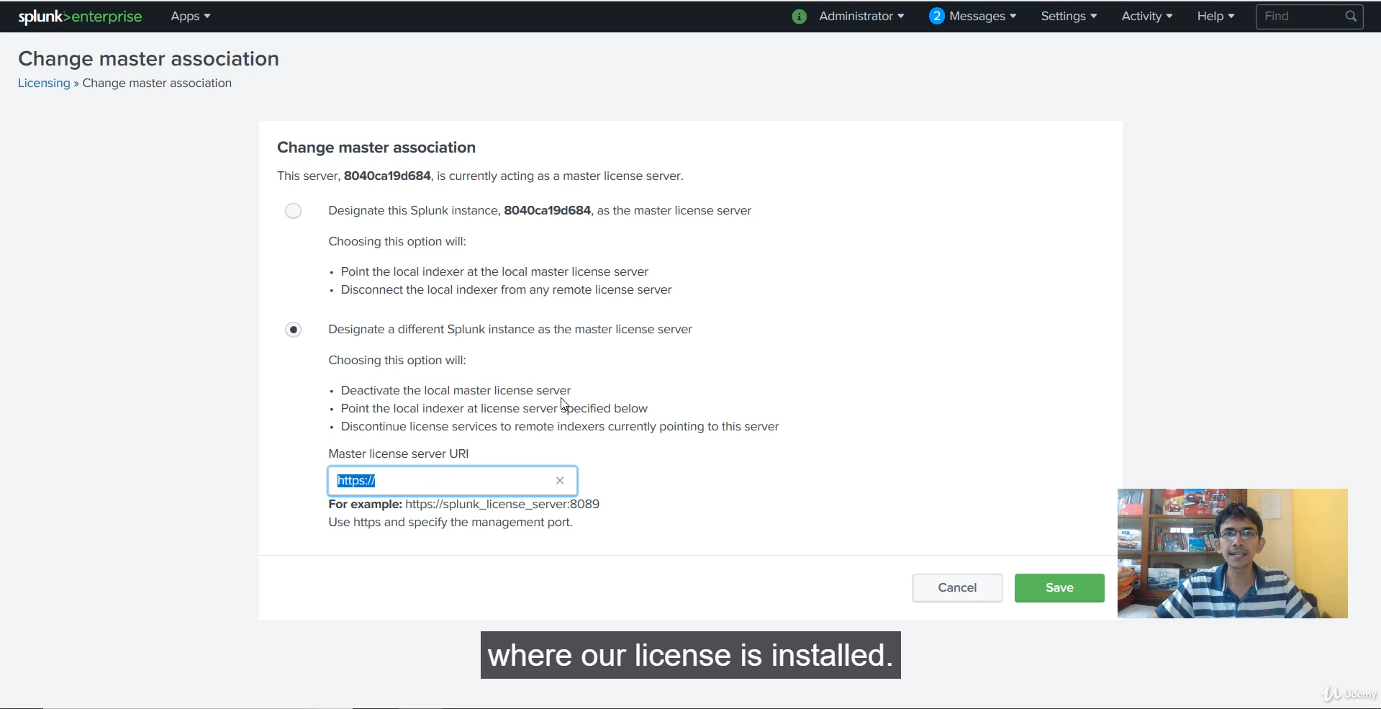

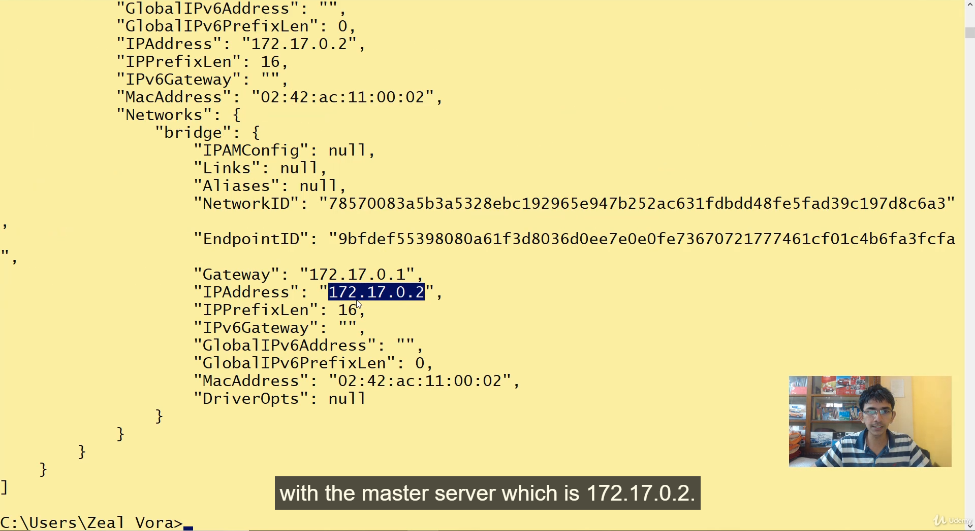

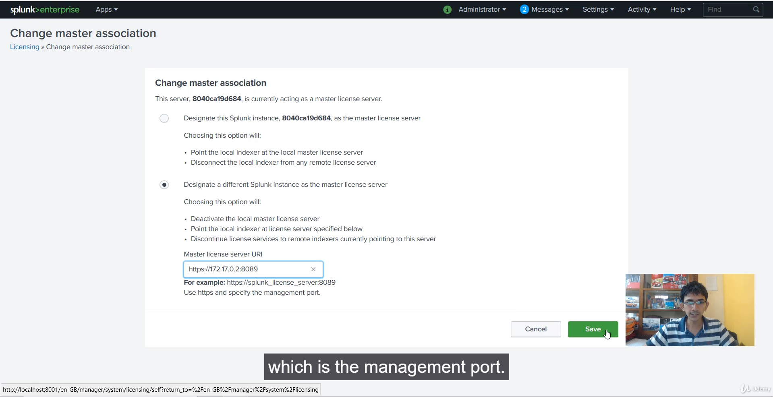

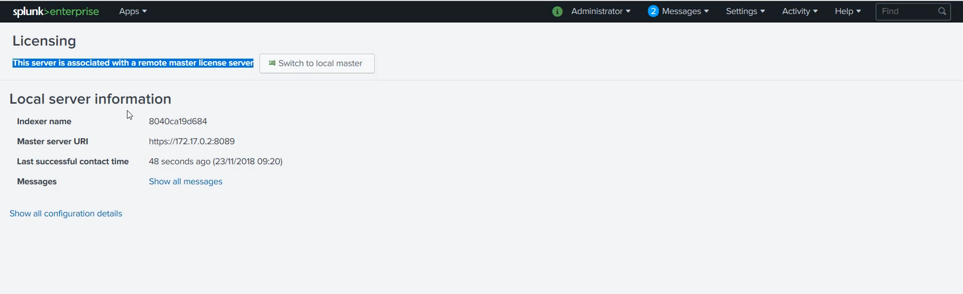

**Splunk License Master-Slave Configuration**

* **1. Designate License Master:** The master Splunk instance (localhost:8000) was designated as the license server via **Settings > Licensing > Change to slave** (and selecting the option to **designate this Splunk instance as the licensing server**).
* **2. Install Enterprise License:** An Enterprise license file (splunk.license) was installed on the License Master, requiring a restart and replacing the trial license. This enabled the *Enterprise License Group* and the **pooling functionality**.
* **3. Configure License Slave:** The slave instance (localhost:8001) was configured to connect to the new master via **Settings > Licensing > Change to slave** (and selecting the option to **designate a different Splunk instance as the master license server**).
* **4. Specify Master URI:** The IP address and **management port ($8089$)** of the master container (172.17.0.2:8089) were used to establish the connection, followed by a restart of the slave.
* **5. Verification:** The slave instance confirmed its association with the **remote master license server**, and the master instance showed the **auto-generated pool** feature.

**💡 Anticipated Next Step: License Pooling**

As the video concluded by mentioning the **auto generated pool enterprise** and that **pooling** would be discussed next, this is the most logical area to focus on.

**License Pooling** is a critical feature managed by the License Master in a distributed environment.

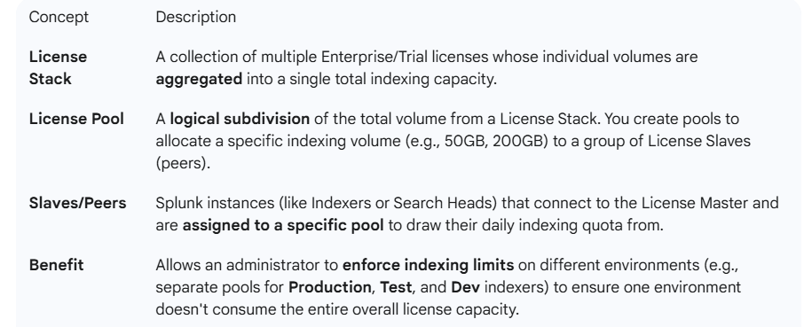

**============================================================================**

1. **License Pools:**

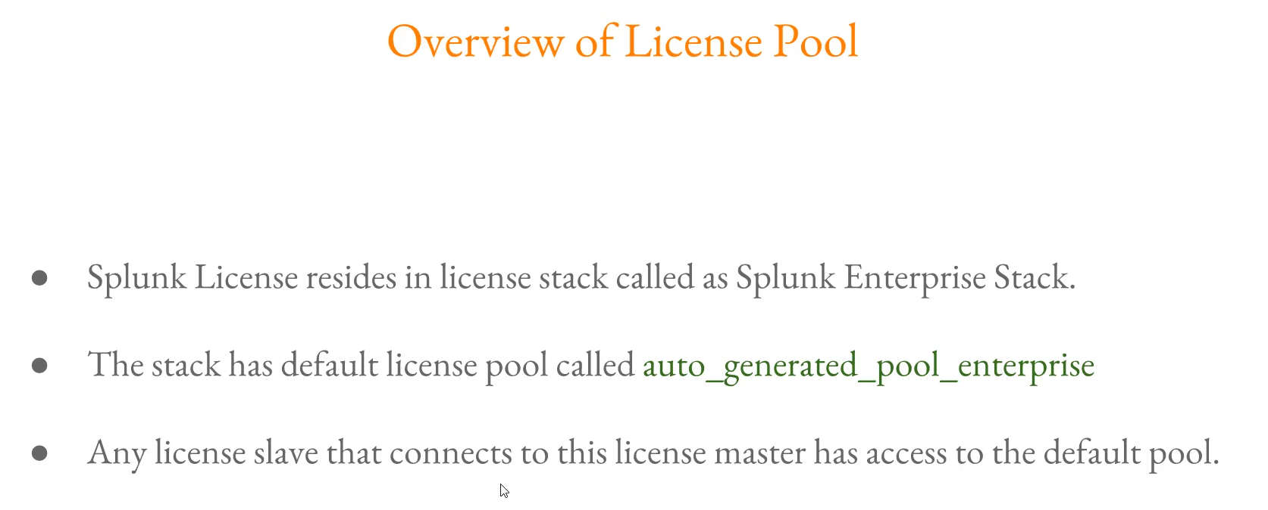

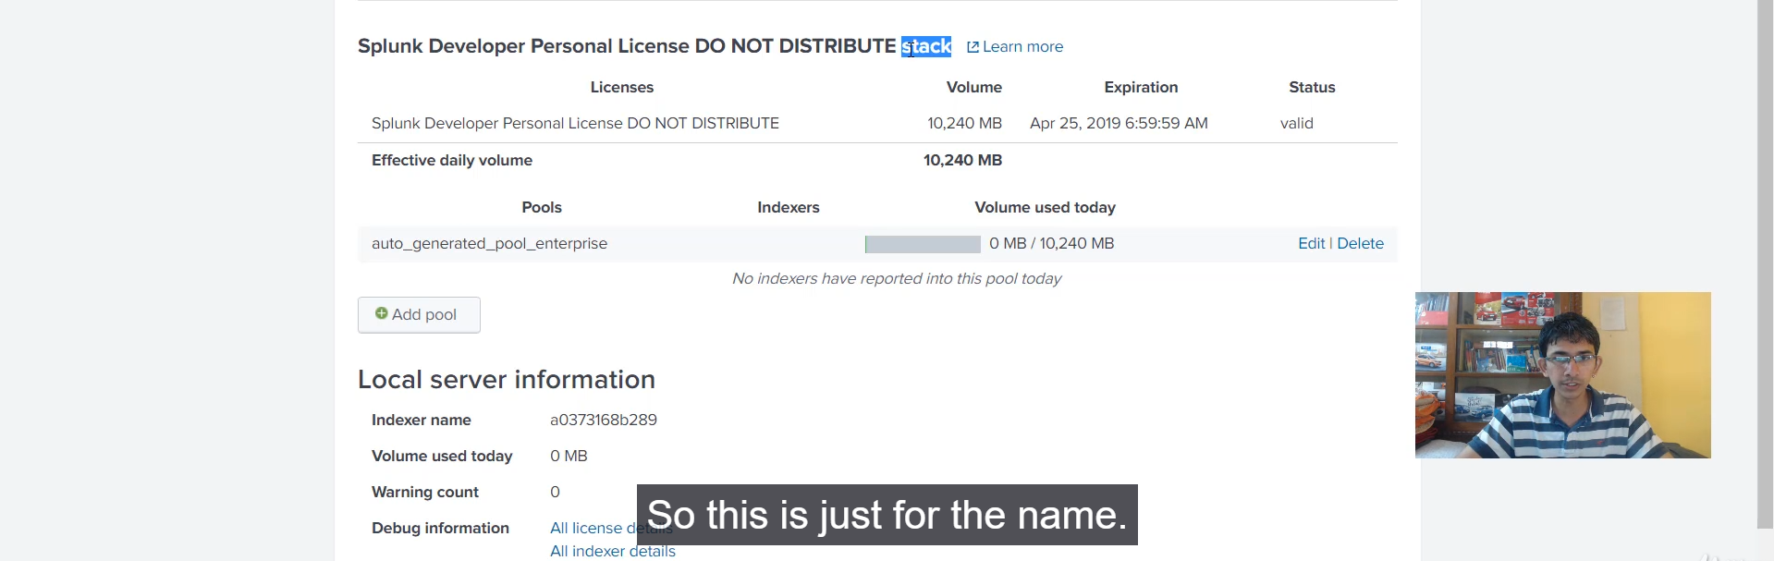

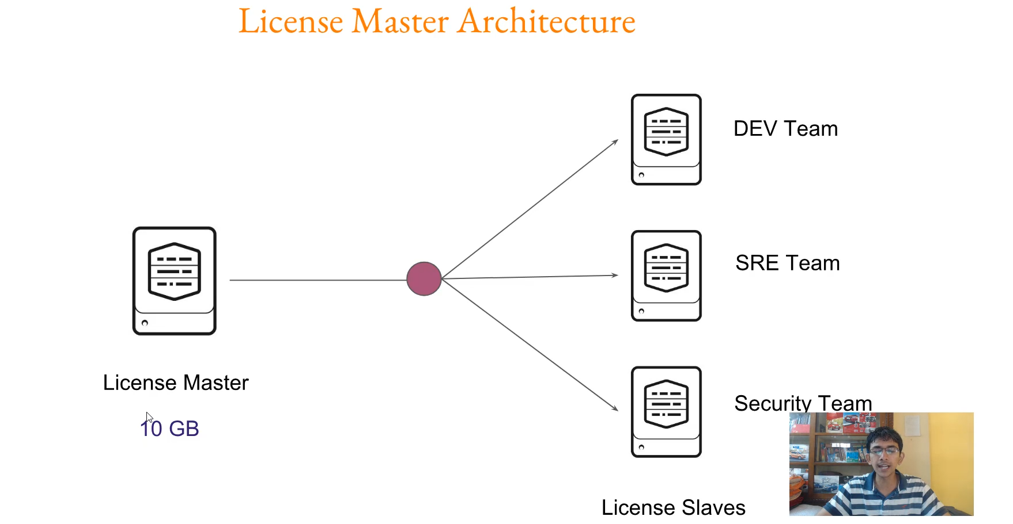

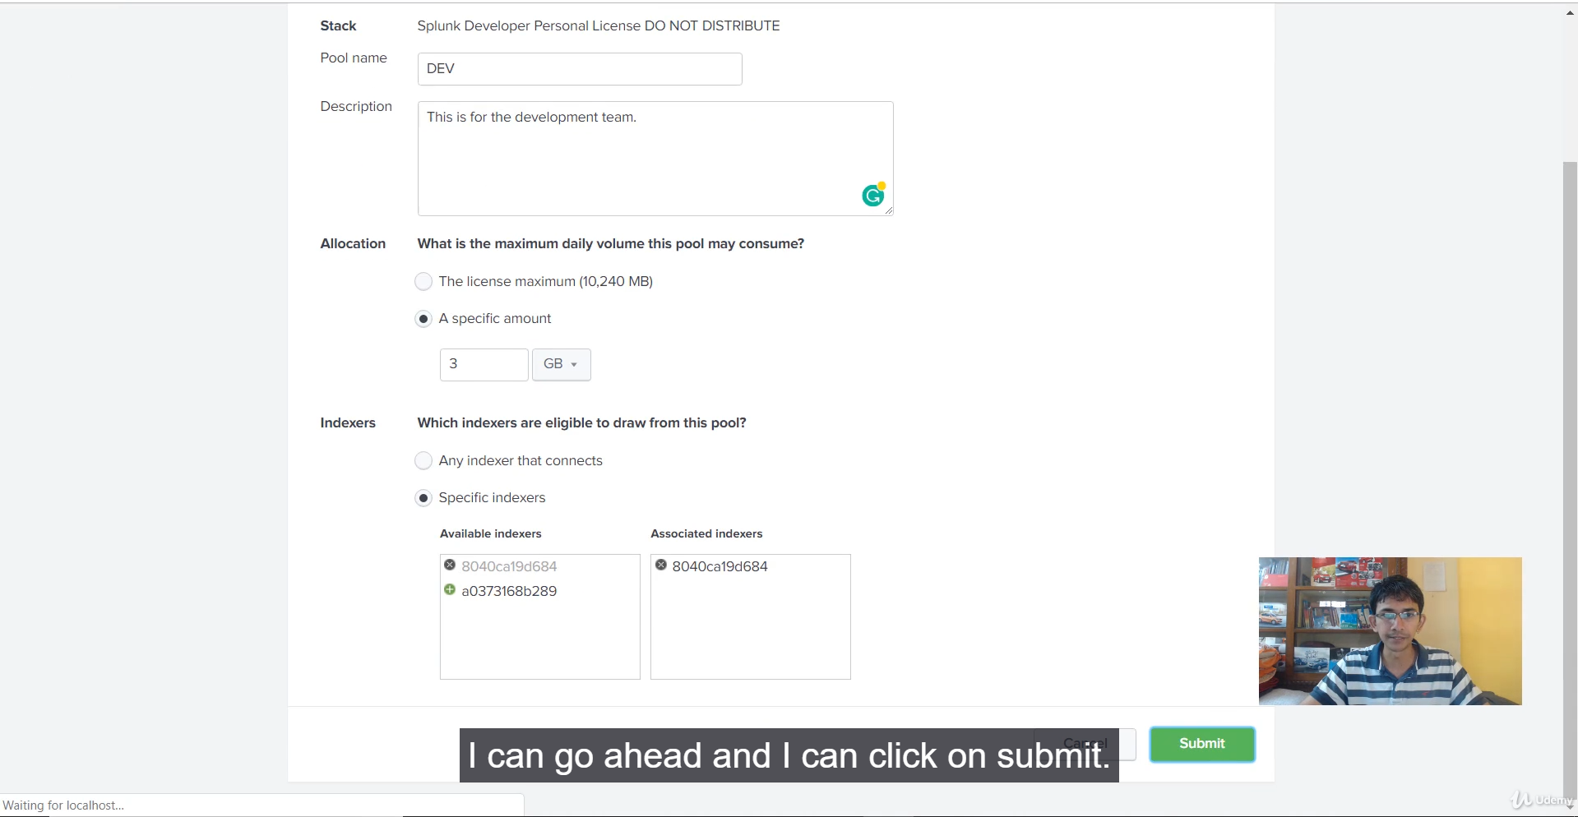

That video provided a clear and practical demonstration of **Splunk license pools** and how to use them for isolating indexing volume among different teams or use cases.

Here is a summary of the key concepts and steps demonstrated:

**💡 Key Concepts of Splunk License Pools**

* **License Stack:** This is where your overall Splunk Enterprise license volume resides. It acts as the central pool of available capacity (e.g., 10 GB/day).
* **Default Pool:** When a license is installed, an **auto-generated pool enterprise** is created by default, consuming 100% of the stack's volume. Any license slave connected to the license master initially has access to this entire pool.
* **The Problem with Default:** Without custom pools, one high-volume indexer (like the **Development Team** in the example) can consume most of the daily license, potentially causing other indexers (**SRE** and **Security**) to hit license warnings/violations.
* **Custom Pools (Isolation):** Creating specific pools (e.g., dev pool, SRE pool, security pool) allows you to allocate a **maximum fixed volume** (quota) of the total license to each team's indexer(s), ensuring fair allocation and preventing one team from starving another.
* **Indexer-to-Pool Restriction:** A critical point is that **one indexer (license slave) can only be associated with one license pool at any given time**.

**🛠️ Steps to Create a New License Pool**

1. **Check/Edit the Default Pool:** The video showed that you cannot create a new pool if the existing auto-generated pool enterprise is consuming 100% of the license stack volume (resulting in the **"Stack is fully allocated"** error).
   * **Action:** You must **edit** the default pool and reduce its maximum allocated volume (or delete it entirely) to free up quota for new custom pools.
2. **Create the New Pool:**
   * **Name & Description:** Specify a unique name (e.g., dev pool) and an optional description.
   * **License Maximum (Quota):** Set the specific volume limit (e.g., 3 GB) that the indexers assigned to this pool can consume daily.
3. **Assign Indexer(s) (License Slaves):**
   * Select the specific indexer(s) (license slaves) that will draw license volume **only** from this newly created pool.
   * **Guardrail:** You are prevented from adding an indexer that is already assigned to another pool.

This segmentation strategy is fundamental to effective Splunk license management in large, multi-team environments.

========================================================================================

1. **Indexer:**

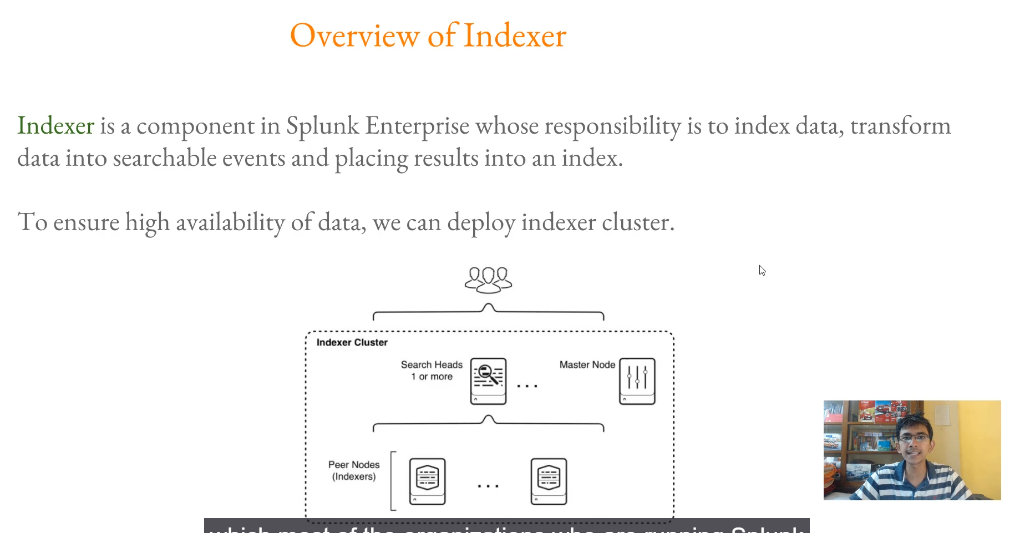

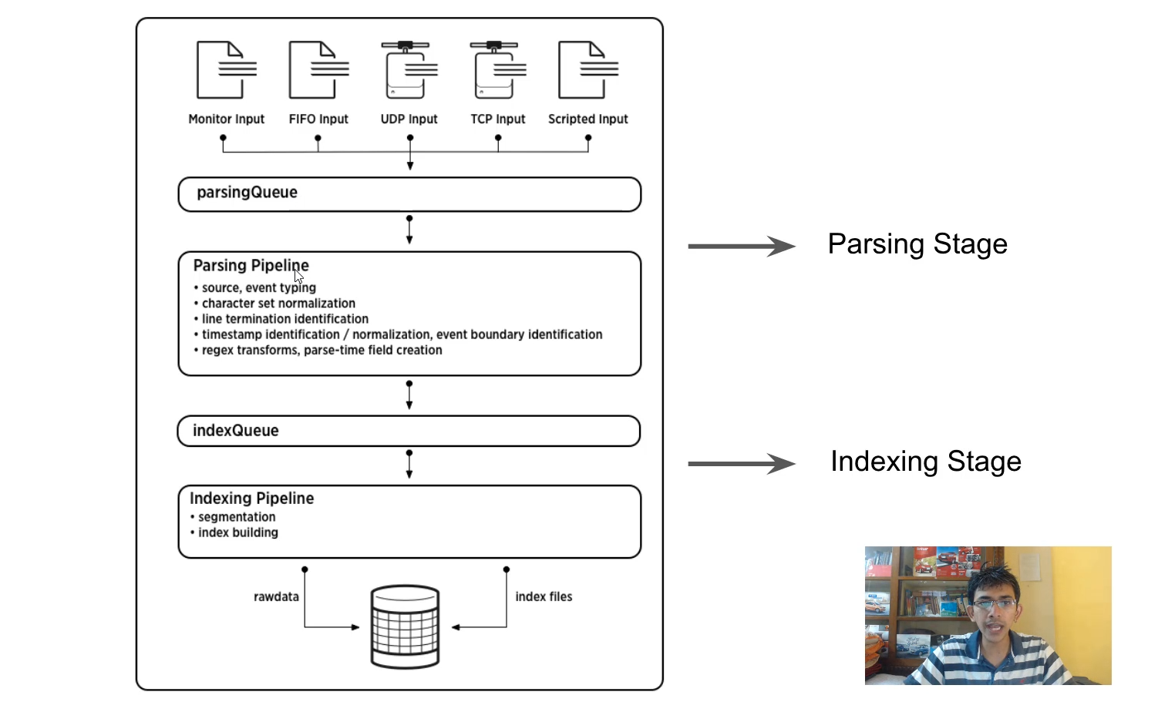

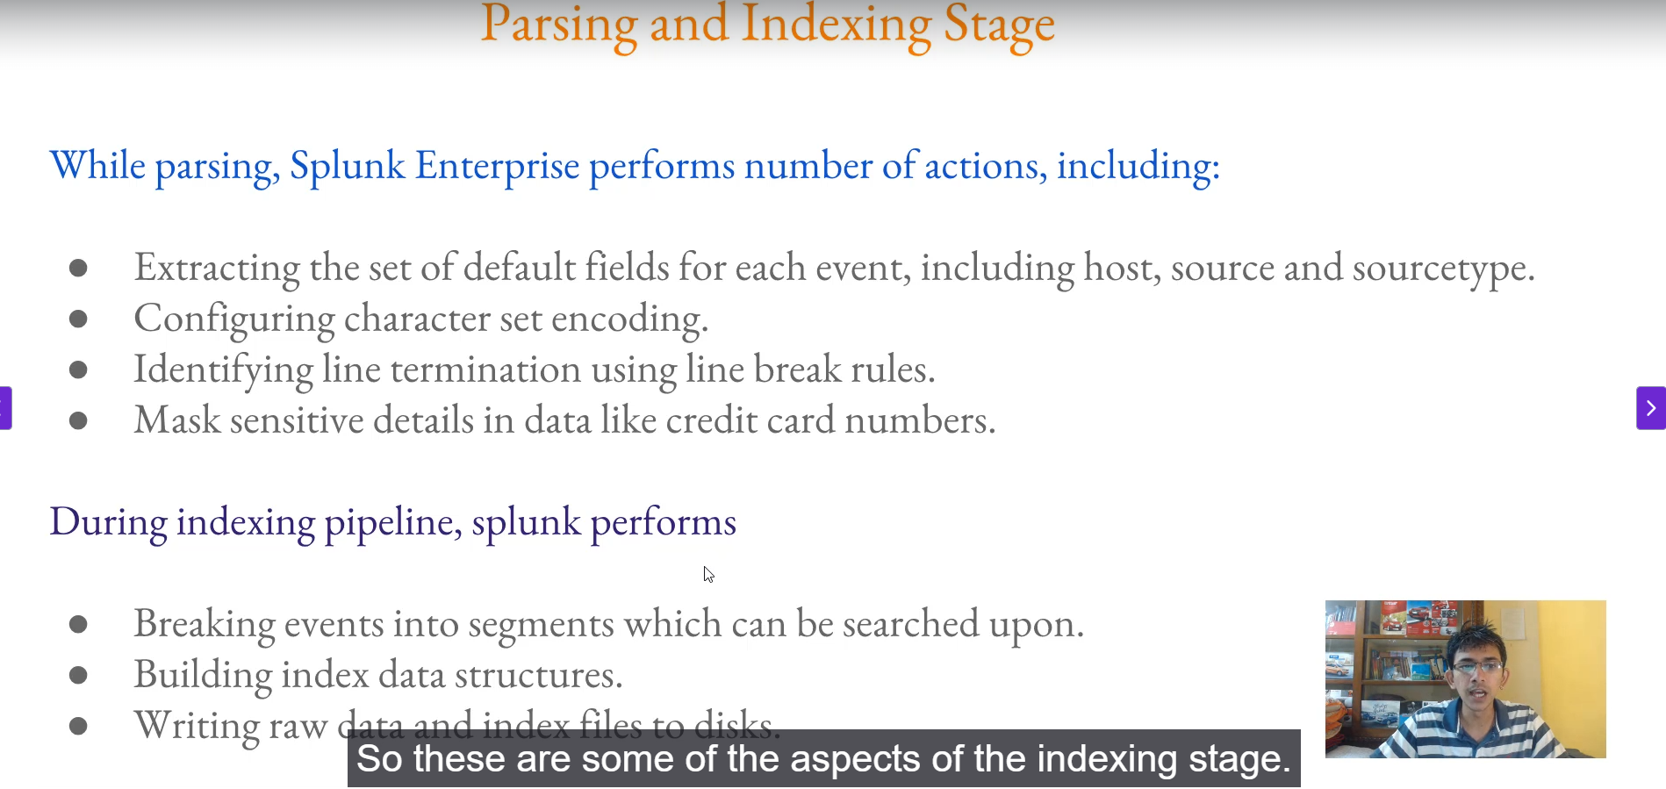

**The Splunk Indexer: Core Responsibilities**

The Indexer is a critical component in a Splunk Enterprise deployment responsible for:

1. **Indexing Data:** Taking incoming raw data.
2. **Transformation:** Converting raw data into searchable events.
3. **Storage:** Placing the results into the appropriate index files on disk.
4. **High Availability:** Clustering capabilities are typically used to ensure the indexer tier remains available (a topic for a future video).

**🌊 The Two-Stage Data Pipeline**

The indexing process is broken down into two main sequential stages, each with its own queue and pipeline:

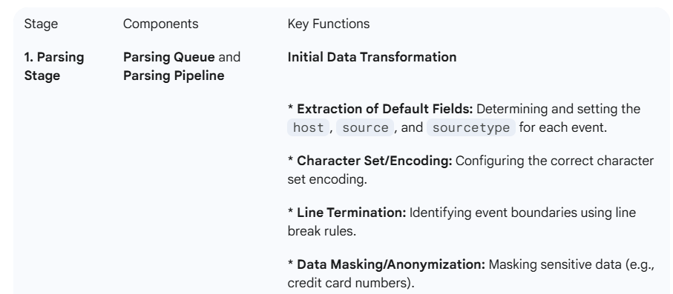

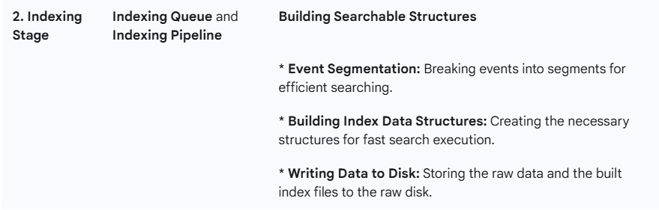

**Data Inputs**

Data enters the parsing queue through various inputs, including:

* Monitor (files and directories)
* TCP/UDP
* Scripted Inputs
* HTTP Event Collector (HEC)

This detailed breakdown highlights how the Indexer meticulously prepares the incoming raw data before it becomes searchable event data.

**============================================================================**

1. **Masking Sensitive Data at Index Time:**

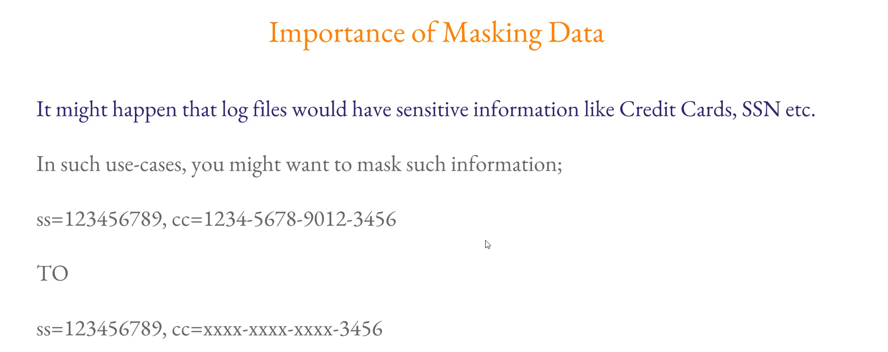

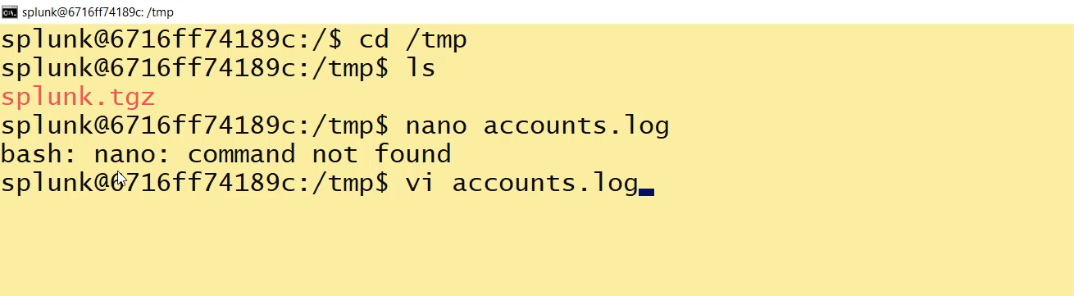

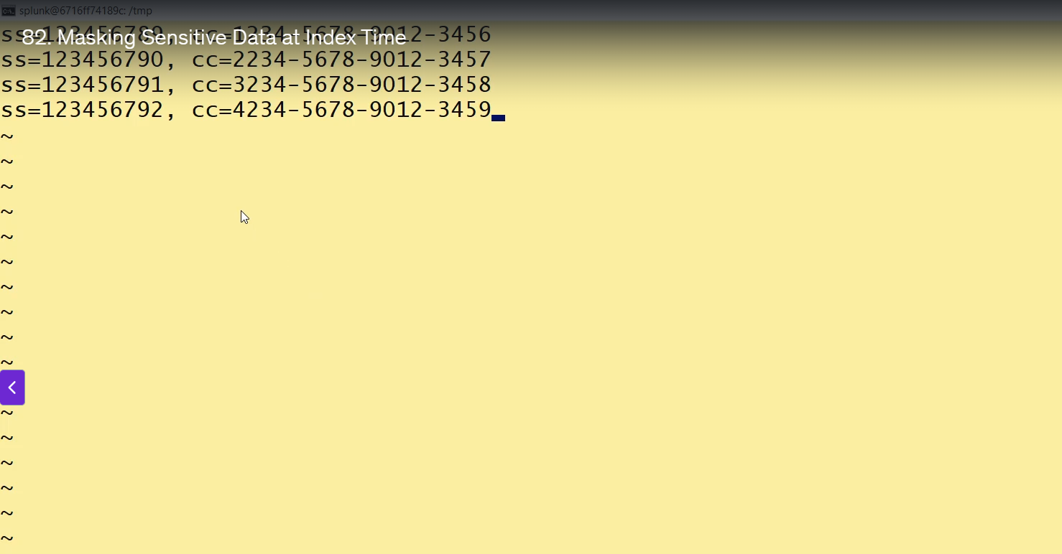

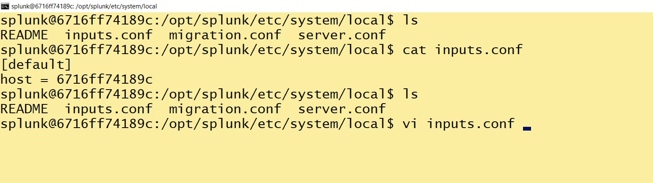  
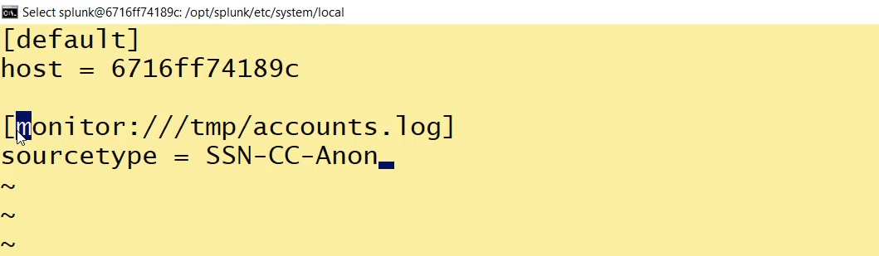

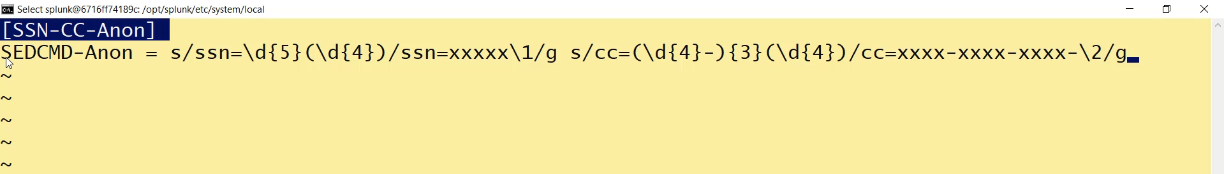

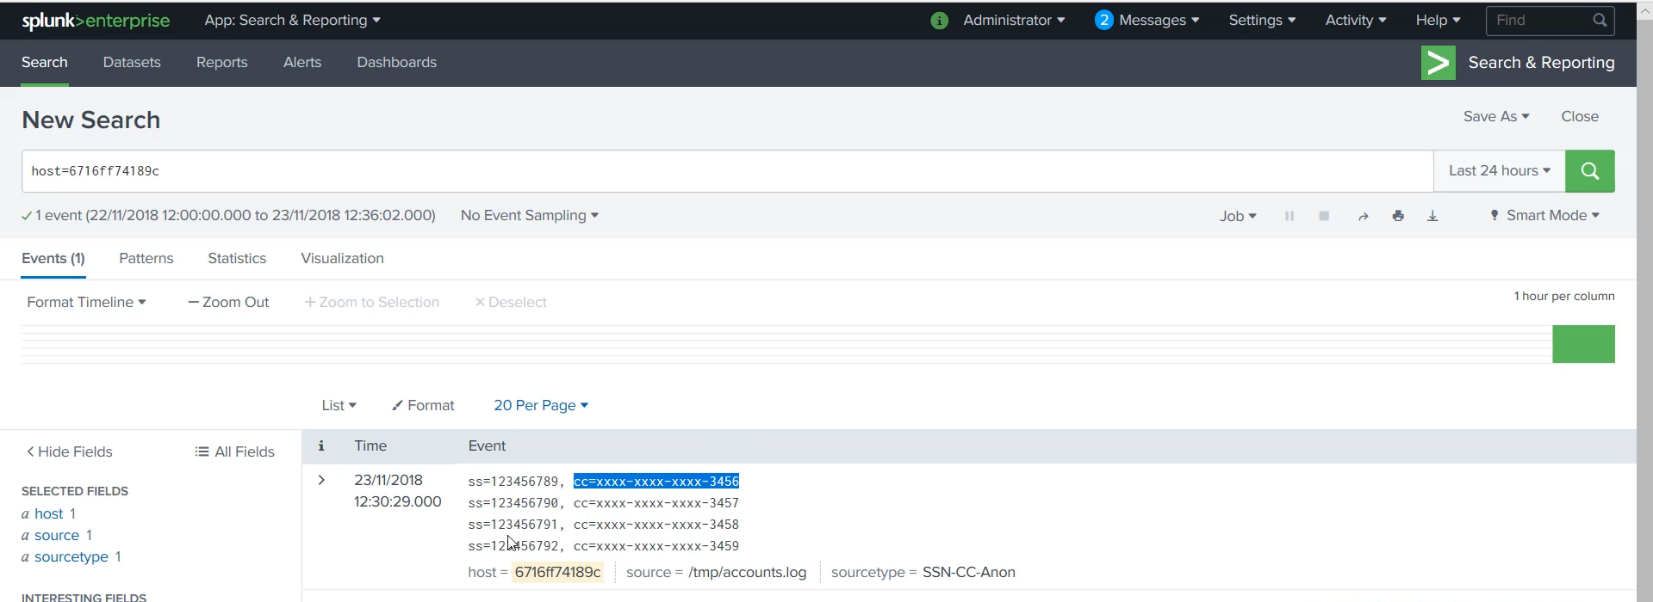

**Core Concept: Data Masking at Index Time**

* **Goal:** To transform sensitive information (like credit card numbers or Social Security Numbers) in the raw log file into a masked format (e.g., XXXXXXXXXX) before it is written to the Splunk index.
* **Pipeline Stage:** This masking occurs during the **Parsing Stage** of the Splunk Indexer pipeline, before the data moves to the Indexing Queue.
* **Why Index Time?** Masking at index time ensures the original sensitive data is **never stored** on disk, which is essential for meeting compliance requirements (e.g., PCI, HIPAA).

**🛠️ Configuration Steps for Masking**

The demonstration used a combination of two configuration files, inputs.conf and props.conf, on the Splunk indexer:

**1. inputs.conf (Data Ingestion)**

This file tells Splunk which file to monitor and assigns a specific sourcetype to the data. This sourcetype is later used in props.conf to target the data for masking.

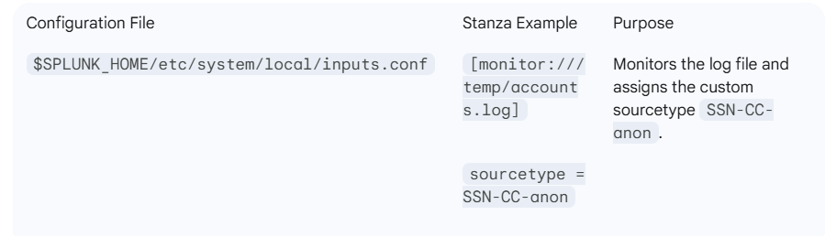

**2. props.conf (Parsing Rules)**

This is where the actual masking rule is defined, using the assigned sourcetype as the target.

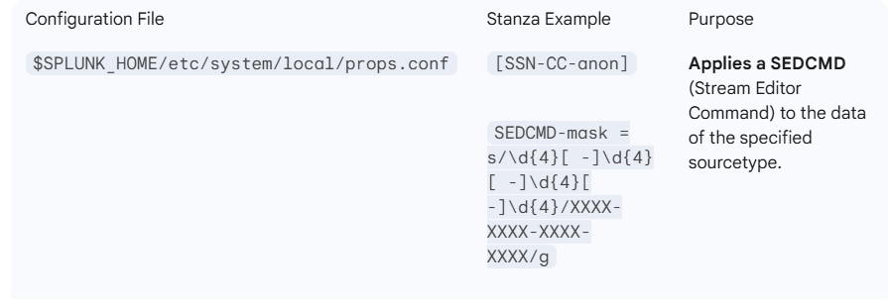

**Key Component: SEDCMD**

* SEDCMD-mask: This function allows the use of a **sed-like syntax** to perform search-and-replace actions on the incoming data stream.
* The **Regular Expression (Regex)** s/\d{4}[ -]\d{4}[ -]\d{4}[ -]\d{4}/XXXX-XXXX-XXXX-XXXX/g is designed to find patterns that look like a credit card number (four groups of four digits separated by a space or hyphen) and replace the entire string with the masked format.

**3. Restart**

After modifying the configuration files (inputs.conf and props.conf), a Splunk restart ($SPLUNK_HOME/bin/splunk restart) is required to apply the new index-time processing settings.

**🔍 Result**

After configuration and restart, when the data is searched in Splunk, the sensitive credit card numbers are displayed in the masked format, confirming the successful transformation during the parsing stage.

**============================================================================**

1. **Search Head:**

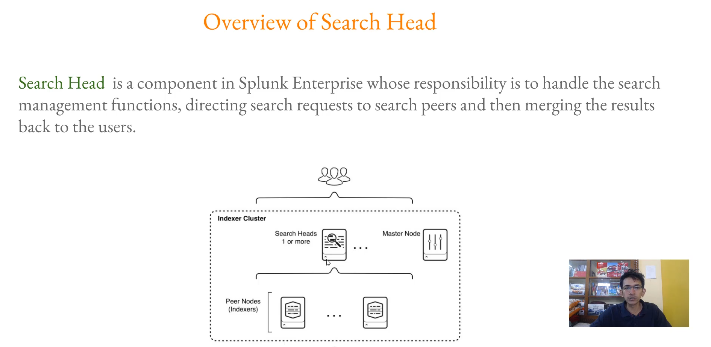

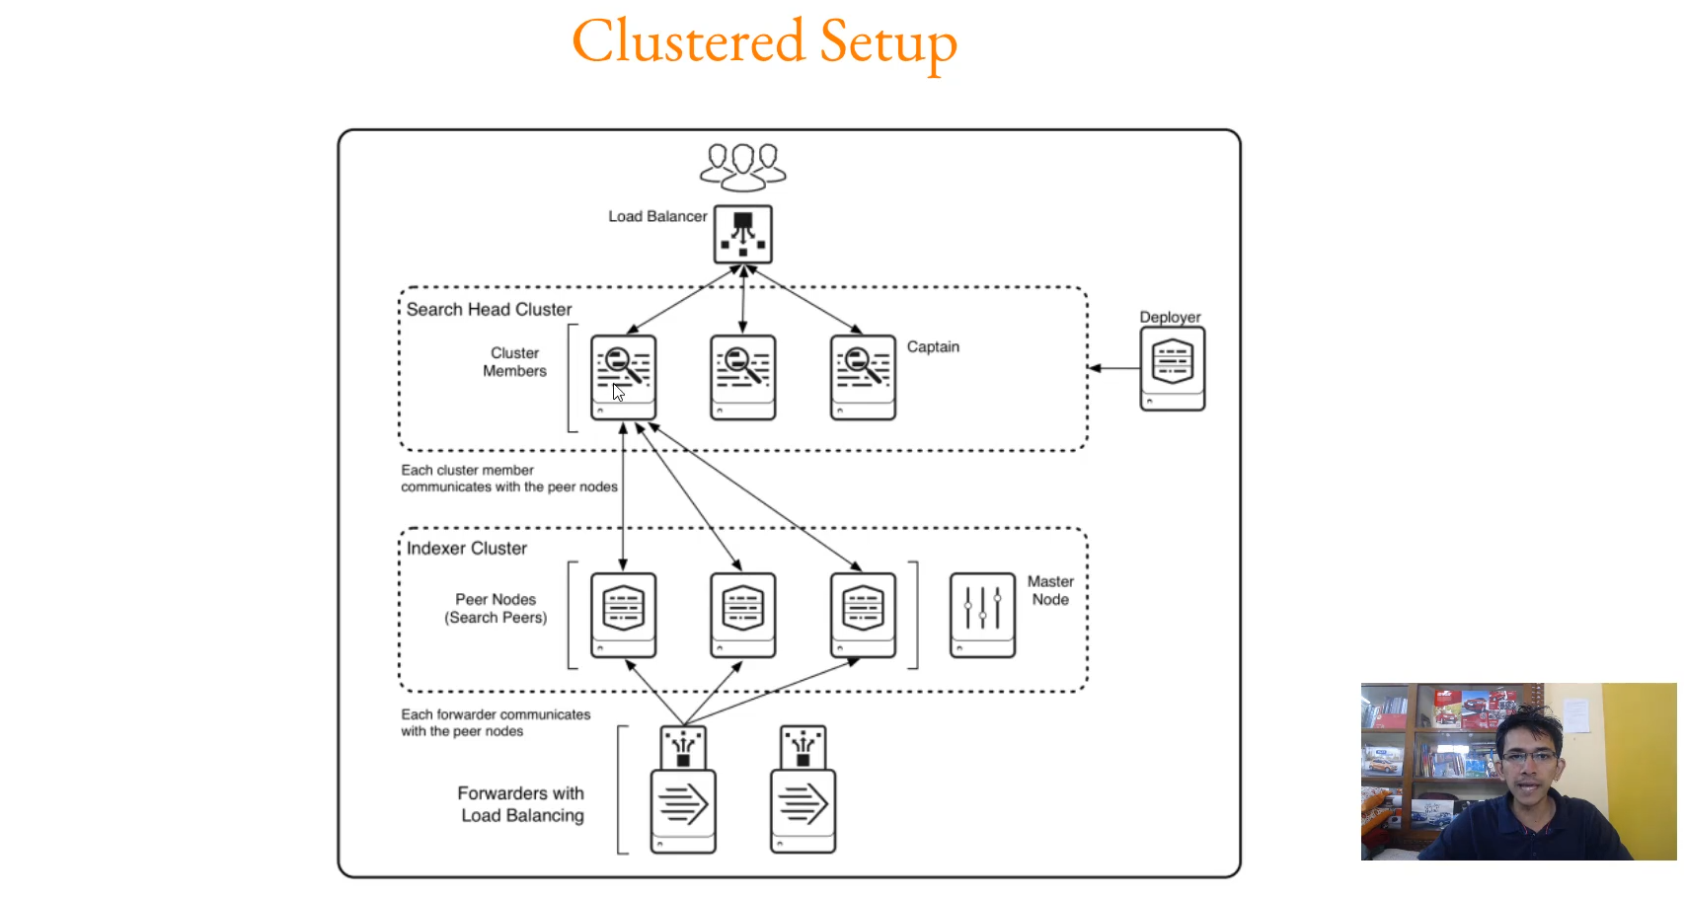

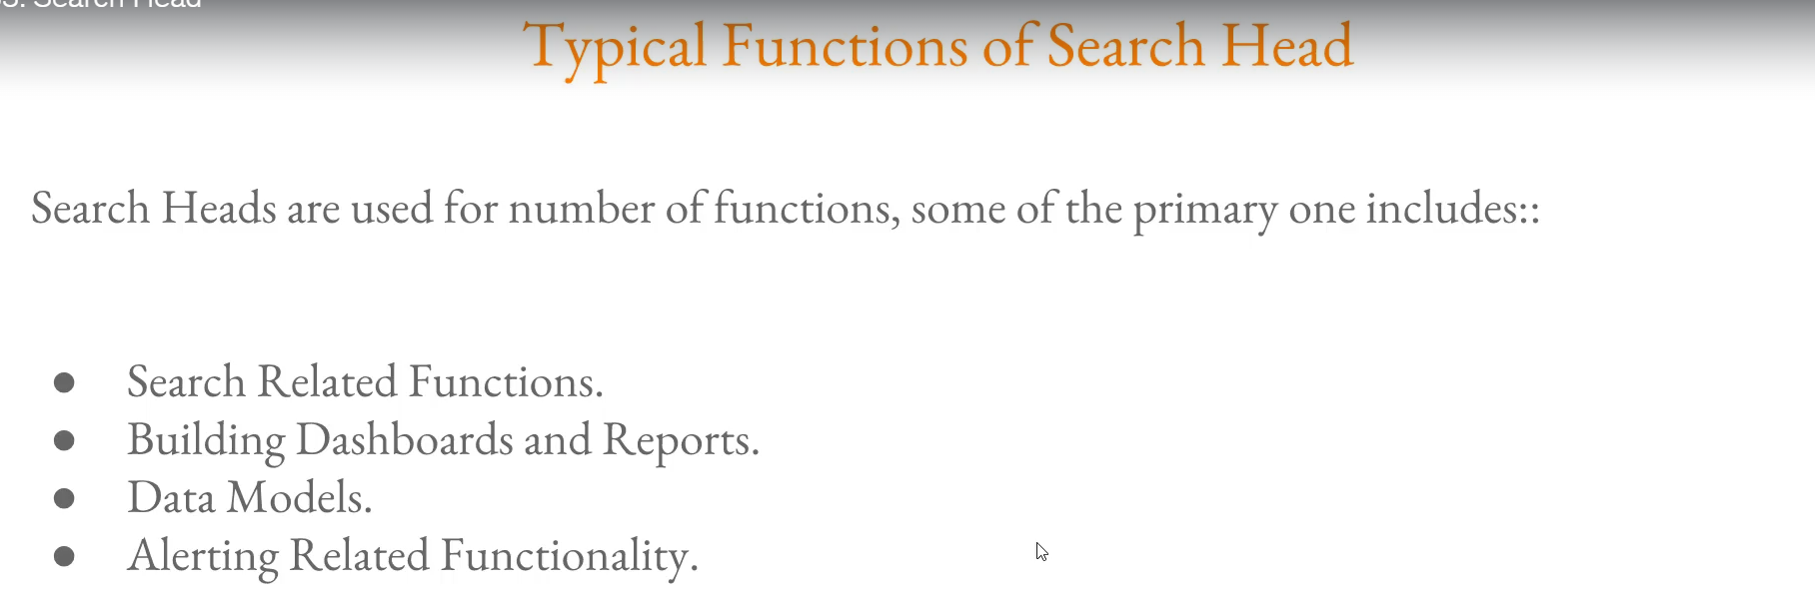

**Splunk Search Head: Core Role**

The Search Head is the user-facing component of a distributed Splunk deployment, dedicated to managing all search-related processes.

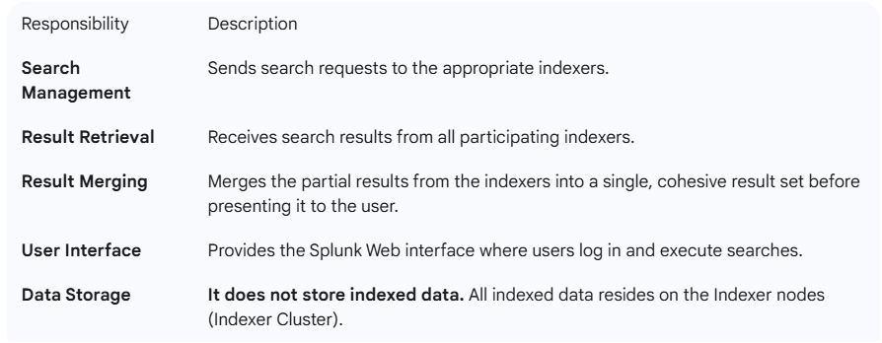

**Key Functions of the Search Head**

The Search Head handles the creation and management of several crucial Splunk artifacts and functionalities:

* **Search and SPL Execution:** The primary function, where users execute Search Processing Language (SPL) queries.
* **Dashboards and Reports:** It is the component used for building, running, and managing custom dashboards and scheduled reports.
* **Alerting:** Logic for setting up and running scheduled alerts is managed here.
* **Data Models:** Used for defining Data Models and managing their acceleration.

**🏢 Search Head Architecture in a Cluster**

In a clustered or distributed setup, the architecture is typically structured to ensure high availability and scalability:

* **Indexer Cluster:** Houses all the indexed data. Forwarders (Universal Forwarders, etc.) send data here for storage and indexing.
* **Search Head Cluster (or standalone Search Head):** Serves as the user access point.
* **Search Flow:**
  1. A user logs into a Splunk instance that is part of the Search Head Cluster.
  2. The user executes an SPL query.
  3. The Search Head sends the request to **all** connected Indexer nodes (peer nodes) in the Indexer Cluster.
  4. Each Indexer searches its local segment of the data.
  5. Indexers return the partial results to the Search Head.
  6. The Search Head combines, aggregates, and processes the results before displaying the final output to the user.

This architecture ensures that search requests can scale horizontally across all available data partitions without the user having to interact directly with the indexers.

===================================================================================

1. **Splunk Monitoring Console:**

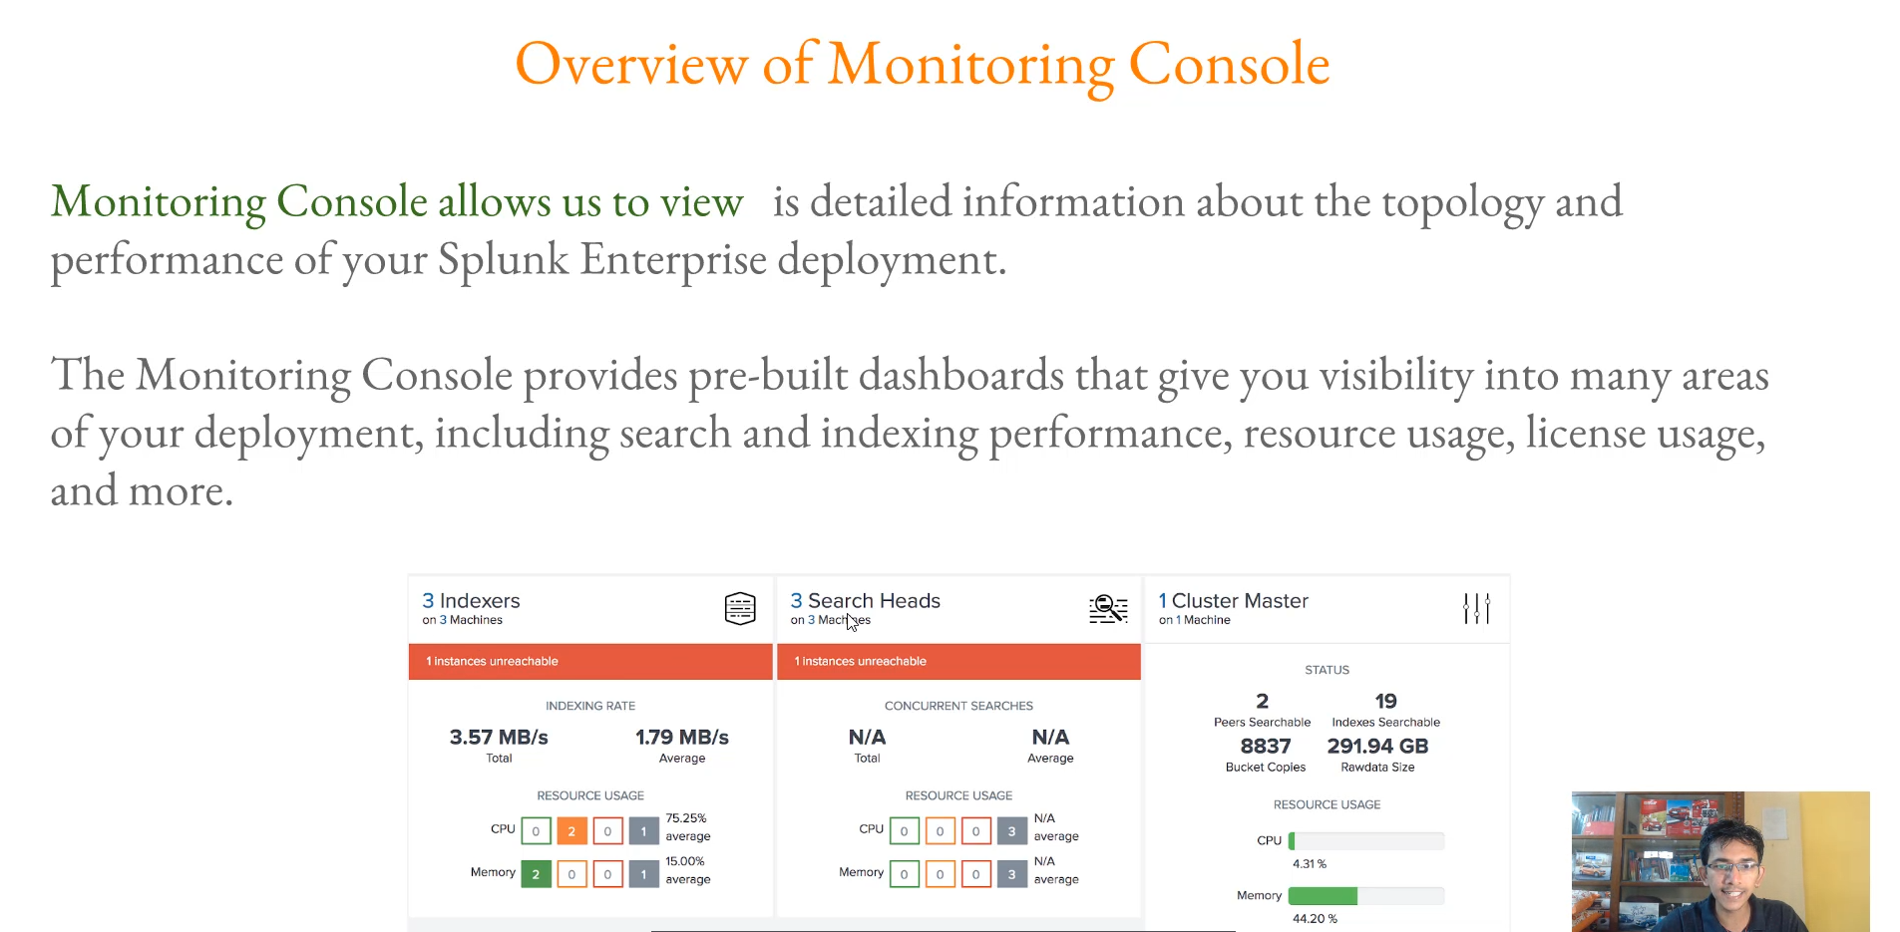

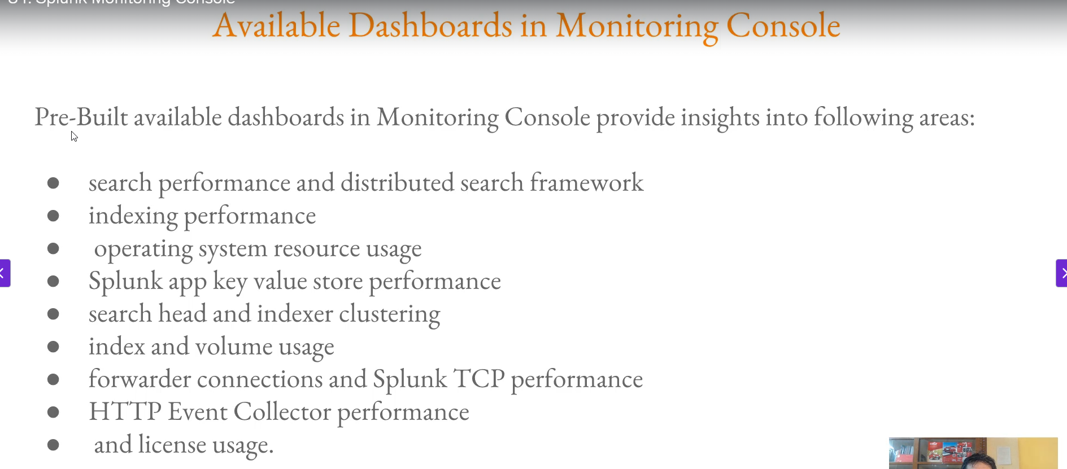

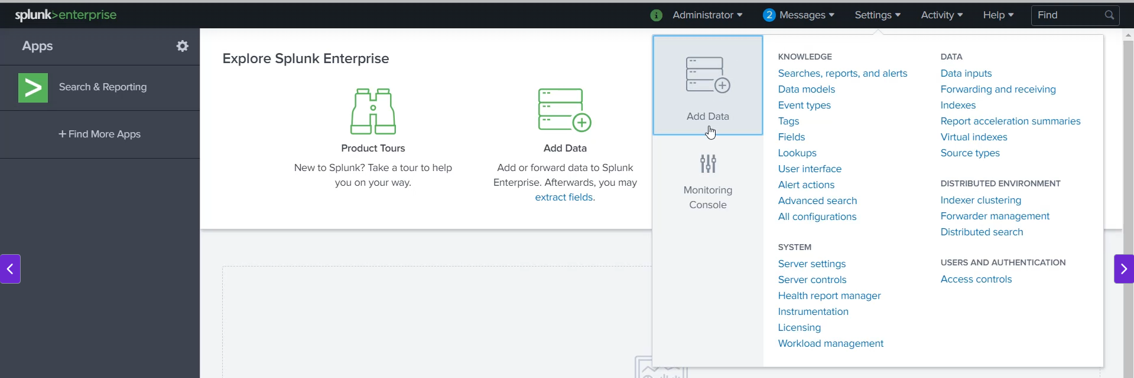

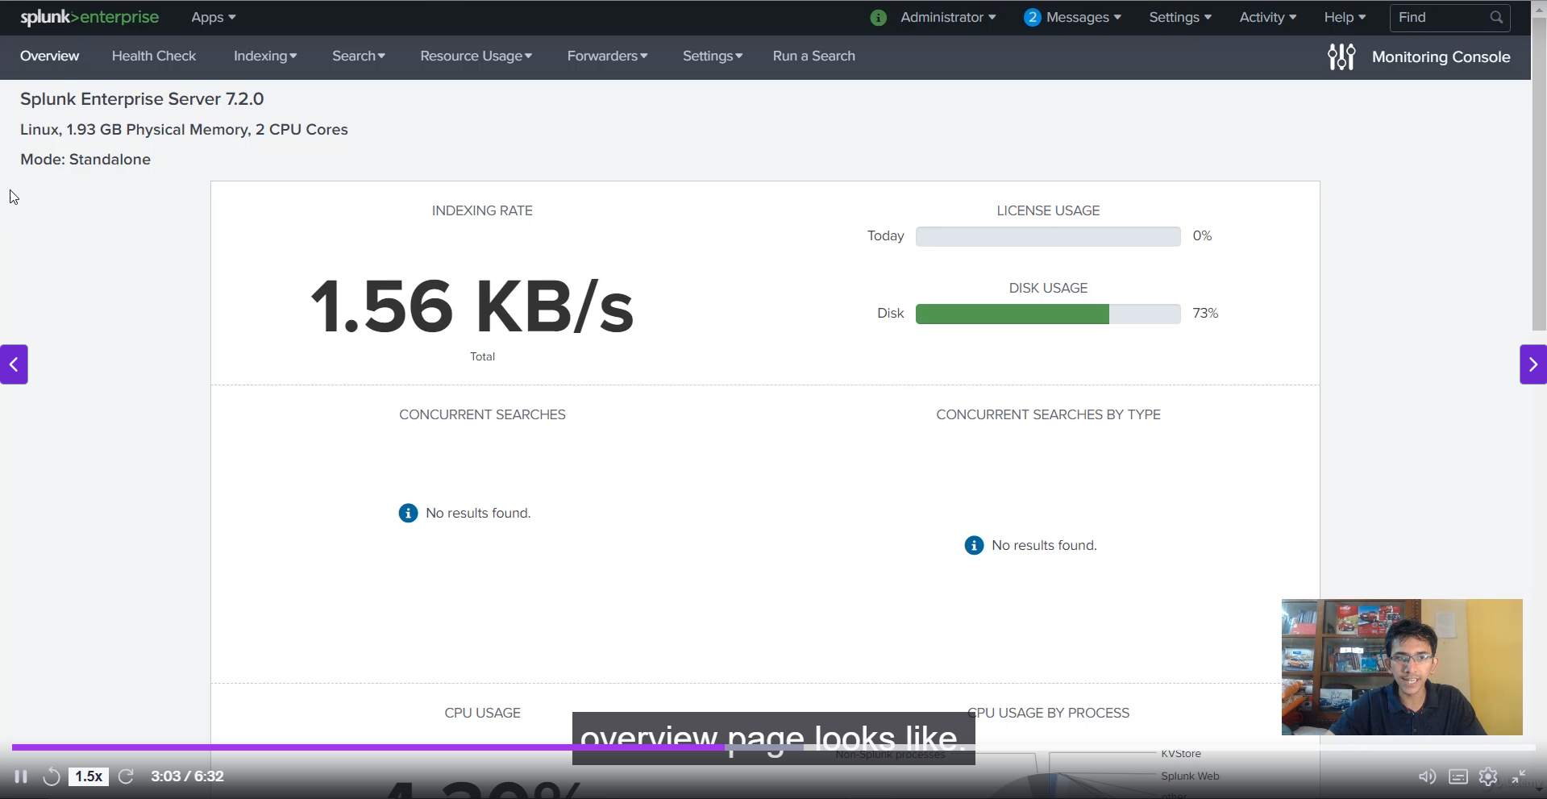

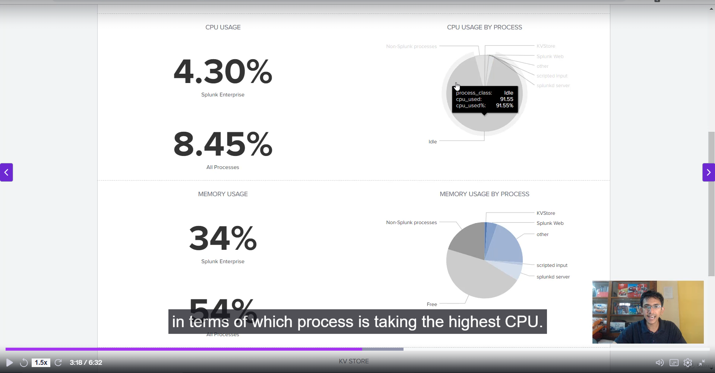

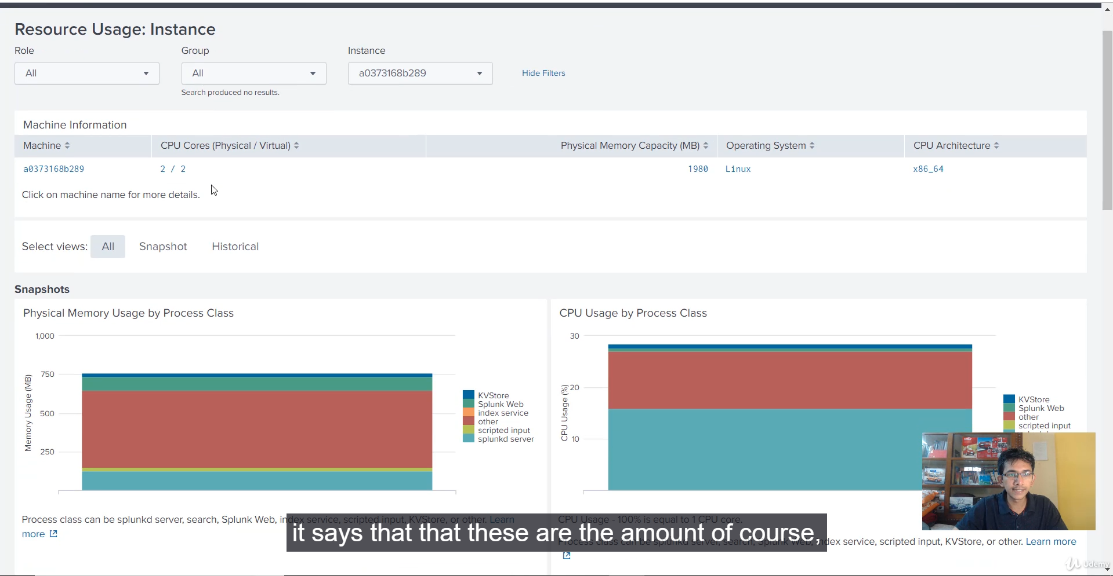

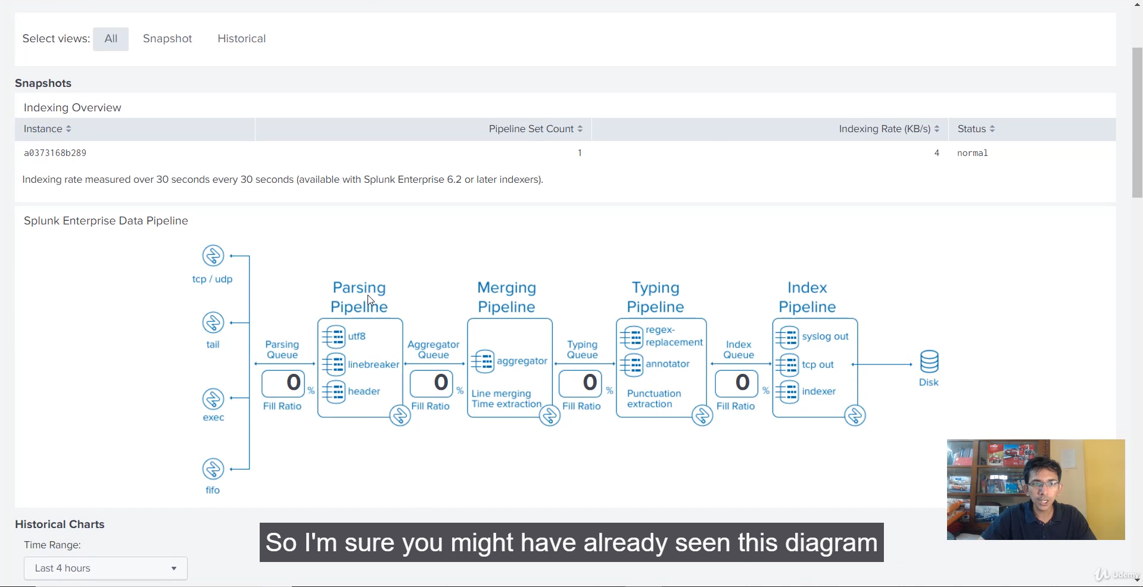

**Splunk Monitoring Console (MC): Overview**

The Monitoring Console is a dashboard-based application that provides detailed visibility into the operational health, performance, and resource utilization of all components within your Splunk environment (indexers, search heads, forwarders, etc.).

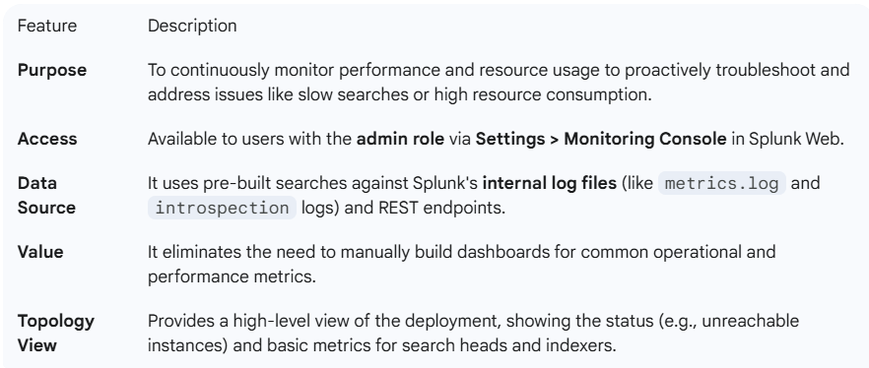

**Key Pre-Built Dashboard Categories**

The MC is organized into several key areas, allowing administrators to focus on specific aspects of deployment health:

**1. Resource Usage**

* **CPU and Memory Usage:** Tracks resource consumption across all instances and by individual Splunk processes. This helps identify resource hogs.
* **Disk Usage:** Monitors disk space for root and Splunk-related partitions (e.g., $SPLUNK_HOME/var/lib/splunk) to prevent disk-full issues.
* **Load Average:** Displays the system load on the underlying machine.

**2. Indexing Performance**

* **Indexing Rate:** Tracks the speed of data ingestion (throughput) in KB/sec.
* **Pipeline Health:** Provides metrics on the **Parsing Queue** and **Indexing Queue** fill ratios, which can help pinpoint bottlenecks in the data processing pipeline.
* **Usage by Source:** Allows drilling down on indexing rate by sourcetype, index, host, and source to identify large data contributors.

**3. Search Usage Statistics**

* **Search Concurrency and Run Time:** Tracks the number of searches running and their median run time.
* **Long Running Searches:** Crucial for identifying searches that consume excessive resources (CPU/memory) and can cause performance lag for other users.
* **Scheduler Activity:** Monitors the performance and health of scheduled searches and reports.

**4. System and Volume**

* **License Usage:** Tracks daily data volume against the Splunk license limit.
* **HTTP Event Collector (HEC) and TCP Performance:** Monitors the performance of specific data input methods.
* **Indexer Clustering Status:** Provides an overview of peer node status, bucket health, and data replication.

**💡 Best Practice**

The video correctly highlighted that the **Monitoring Console is an essential tool for any production Splunk environment**. Regularly reviewing metrics, especially **long running searches** and **queue fill ratios**, allows administrators to maintain a stable, high-performing environment.

******************************************************************************************************************************************************************************************************************************************************************************************

**Core Data & Search Components:**

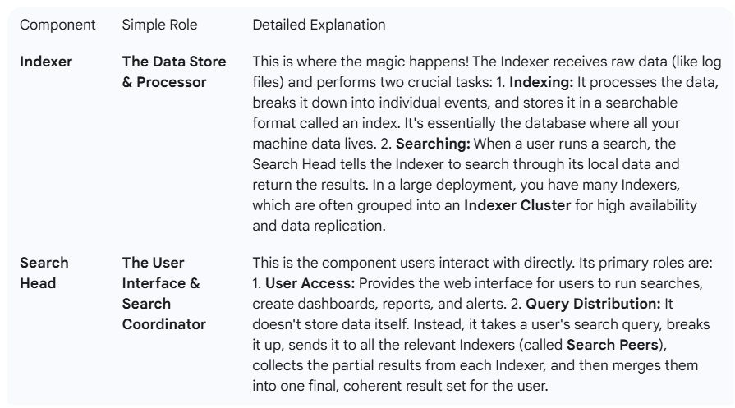

**Management and System Components:**

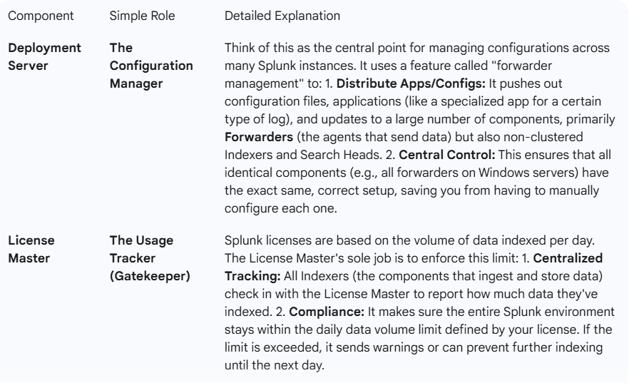

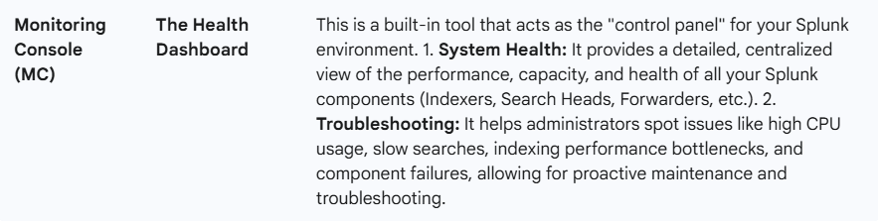

**Putting It Together (The Flow)**

Imagine you run a search for an error in your logs:

1. You log into the **Search Head** and run your query.
2. The **Search Head** coordinates and sends that query to all the **Indexers**.
3. Each **Indexer** searches its own stored data and sends the results back.
4. The **Search Head** combines those results and shows them to you.
5. All the while, the **License Master** is tracking the data volume being ingested by the **Indexers**.
6. The **Deployment Server** is ensuring all your data collection agents (Forwarders) are using the latest configurations.
7. The admin uses the **Monitoring Console** to make sure everyone is healthy and running fast.

**========================================================================================**